**Linux Module1 Exercise:**

1. Creating users in Linux:

* Which command is used to create a new user in Linux?

useradd username

adduser username

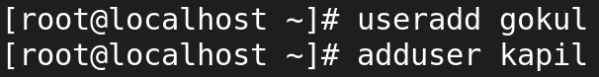

* What is the syntax for creating a user using the useradd command?

Useradd -(optional) username

* Can you create a user with specific user ID (UID) and group ID (GID) using the useradd command? If yes, how?

Yes,we can create both uid and gid when useradd 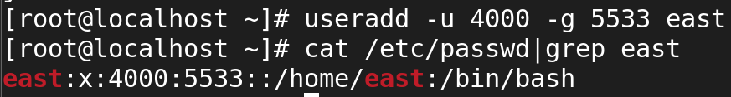

* How can you set an initial password for a newly created user?

Passwd username

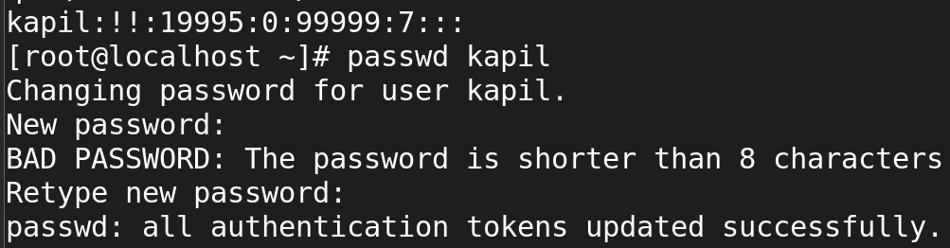



* What happens if you try to create a user with a username that already exists on the system?

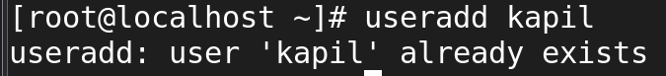

If the username already exists, you'll need to create a new user with a unique username.

* Is it possible to create a user without a home directory? If yes, how?

Yes , we can create by using useradd -m optional username

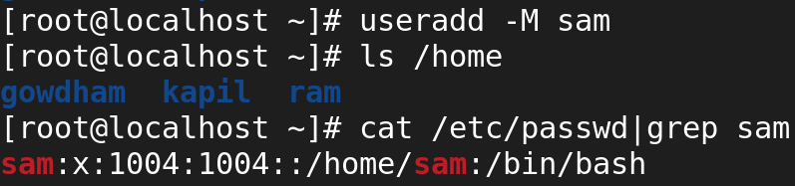

* How can you specify the shell for a user during creation?

1. **Most Common**: Bash (/bin/bash)
2. **Power Users**: Zsh (/bin/zsh)
3. **Scripting**: Dash (/bin/dash) **or Bourne shell** (/bin/sh)
4. **Friendly Interactive Shell**: Fish (/usr/bin/fish)

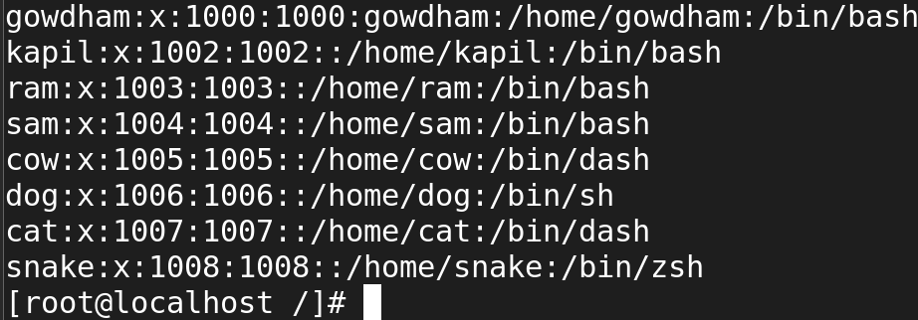

* Can you create a user with additional supplementary groups using the useradd command? If yes, how?
* How can you verify that a user has been successfully created?

**Cat /etc/passwd(user detail)**

**ls /home(user directory)**

**Id username**

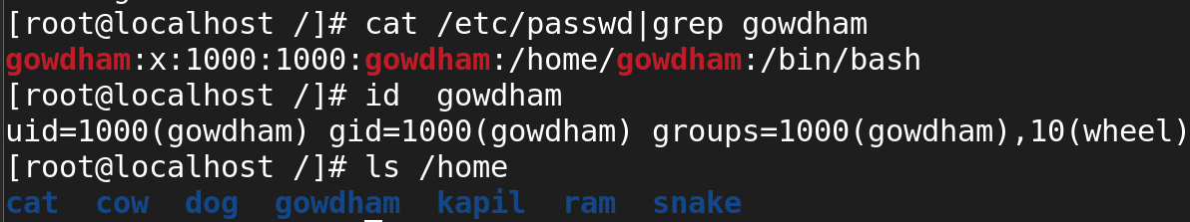

* Is there a way to create a user with a specific expiration date? If yes, how?

**useradd -e 2024-12-23 dada**

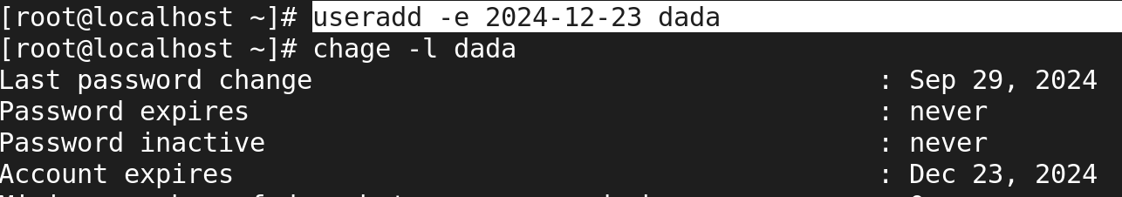

**2. cat command in Linux:**

* What is the purpose of the cat command in Linux?

The cat command in Linux is a versatile utility primarily used for displaying the contents of files, concatenating files, and creating new files. The name "cat" is short for "concatenate." Here are the main purposes and functionalities of the cat command:

· **Display a text file**: cat filename.txt

· **Create a new file**: cat > newfile.txt

· **Concatenate files**: cat file1.txt file2.txt > combined.txt

· **Append to an existing file**: cat additional.txt >> existingfile.txt

· **View with line numbers**: cat -n myscript.sh

· **View with non-printing characters**: cat -v myfile.txt

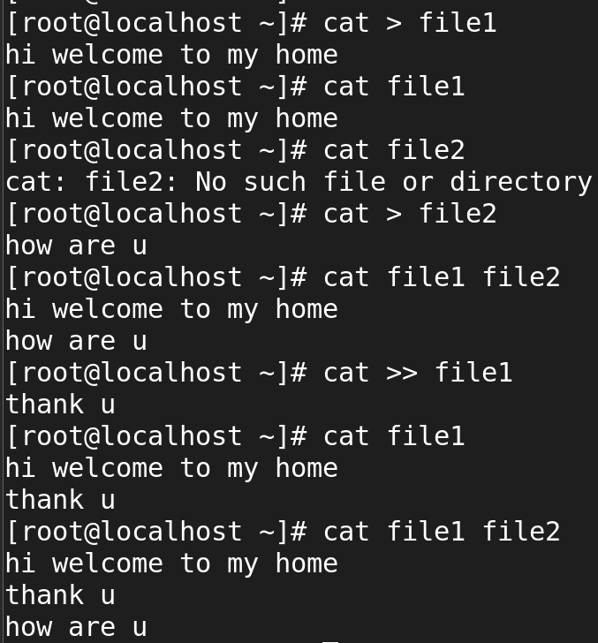

* How do I use the cat command to display the contents of a file on the terminal?

**Display a content of file**: **cat filename.txt**

* Can cat display the contents of multiple files at once?

Yes, the cat command can display the contents of multiple files at once. When you provide multiple filenames as arguments to the cat command, it will concatenate their contents and display them sequentially in the terminal.

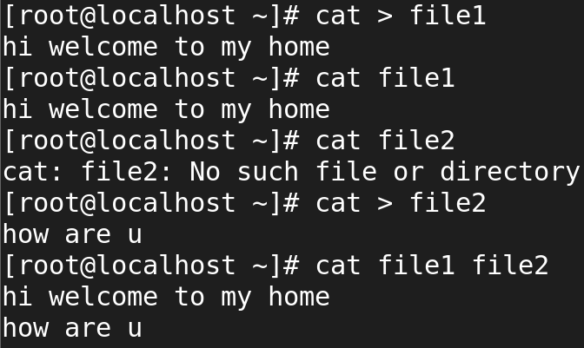

* What are some options available with the cat command, and how do I use them?

The cat command in Linux comes with several useful options that enhance its functionality for displaying and manipulating text files. Here are some of the most commonly used options along with explanations and examples:

· **-n:** Number all lines.

·  **-b**: Number only non-blank lines.

· **-s**: Suppress repeated empty lines.

· **-A**: Show all non-printing characters.

· **-v:** Show non-printing characters.

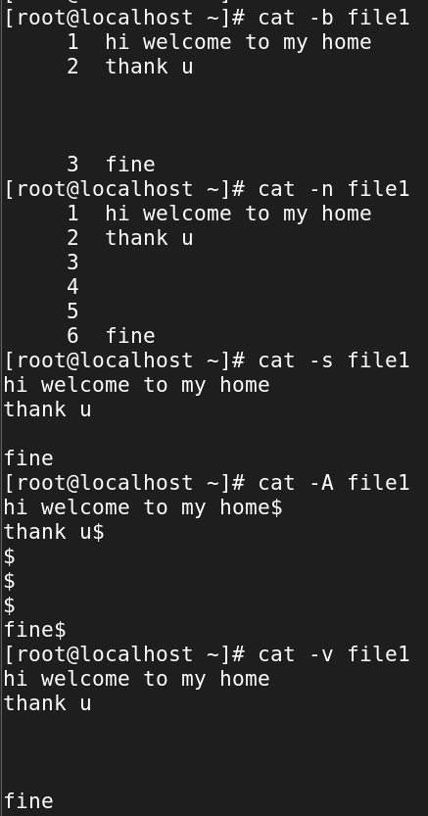

* How can I create a new file using the cat command?

Command use to create a new file:**cat > filename.txt**

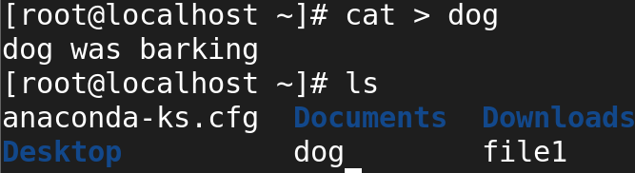

* Is it possible to concatenate multiple files using cat? If yes, how?

Yes , we can do it : **cat file1 dog**

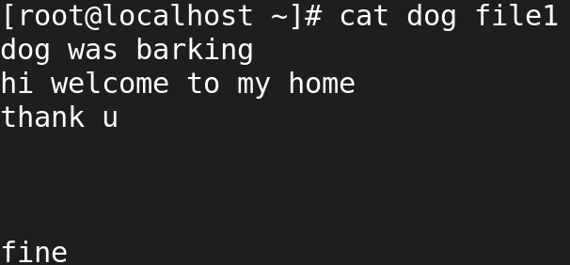

* How does the cat command handle binary files?
* Can I number the lines while displaying the contents of a file with cat?

Yes , by using cat -n filename

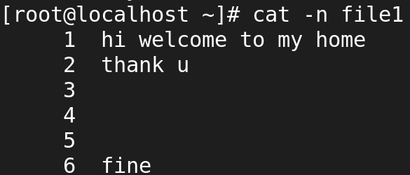

* How do I suppress the display of trailing whitespace in cat output?
* Can I use cat to append the contents of one file to another?

Yes , we can appened the current content with existing file.

**Cat >> filename.txt**

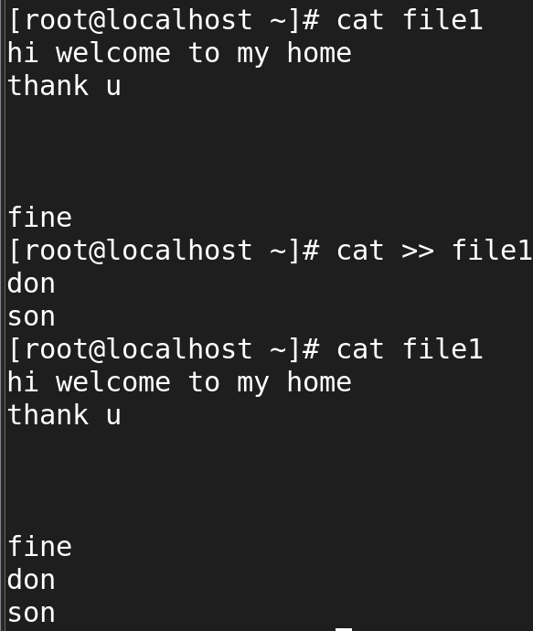

* Is it possible to create a copy of a file using the cat command?

Yes, it is possible to create a copy of a file using the cat command in Linux. This can be done by redirecting the output of cat into a new file. Here’s how to do it:

cat sourcefile > desinitionfile

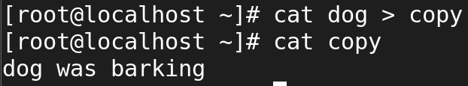

* How can I use cat to display non-printing characters like tabs and newlines as visible characters?

You can use the cat command with the -A option to display non-printing characters, such as tabs and newlines

The -A option in cat shows:

* **Tabs** as ^I
* **Newlines** as $ at the end of each line

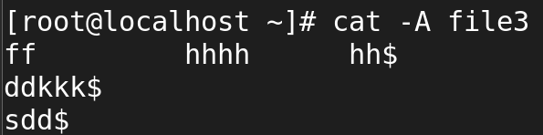

* What happens if I use cat with multiple files, but some of them do not exist?

When you use the cat command with multiple files, and some of the specified files do not exist, cat will attempt to display the contents of the existing files but will output an error message for each file that does not exist. The command will continue to process the remaining files that exist.

The file is not there but we give an file name it dosenot exit.

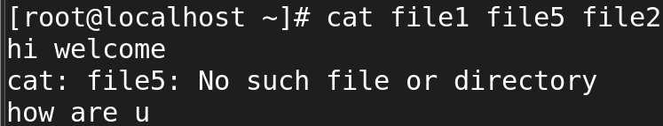

* Can cat be used to view the contents of remote files over SSH?
* How does the cat command handle files with very long lines?

**3. “ls” command in Linux:**

* What is the purpose of the ls command in Linux?

The purpose of ls command was to viwe all files and directory.The ls command in Linux is used to list the contents of directories. It is one of the most commonly used commands in Linux for viewing files, directories, and their attributes. It provides information about the files and directories within a specified directory (or the current directory by default).

* How do I use the ls command to list files and directories in the current directory?

Command ---> ls

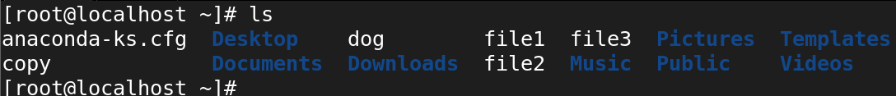

* Can ls display file and directory details, such as permissions, owner, size, and modification date?

Yse , by using command ls -l which is used to show all files and directory with detailed.

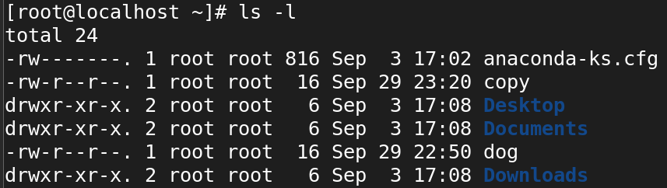

* How can I list files and directories in a specific directory other than the current one?

Command ---> ls -ld

To list files and directories in a specific directory other than the current one using the ls command, you simply need to provide the path to that directory as an argument after the ls command.

Ls ---> /home/gowdham/

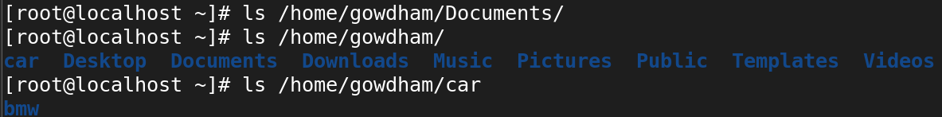

* What are some common options that can be used with the ls command, and how do I use them?

Ls -ld , ls -la , ls -lh , ls -ls , ls -lt , ls -lr , ls -lR

-l: Long listing format (detailed info about files)

· -a: Include hidden files (files starting with .)

· -h: Display sizes in human-readable format (e.g., KB, MB)

· -t: Sort by modification time, newest first

· -S: Sort by file size, largest first

· -r: Reverse the order of the sort

· -R: Recursively list all subdirectories and files

· -F: Append indicators for file types (e.g., / for directories)

* How can I make ls show hidden files and directories?

Ls -la is used to show all hiden files and directory.

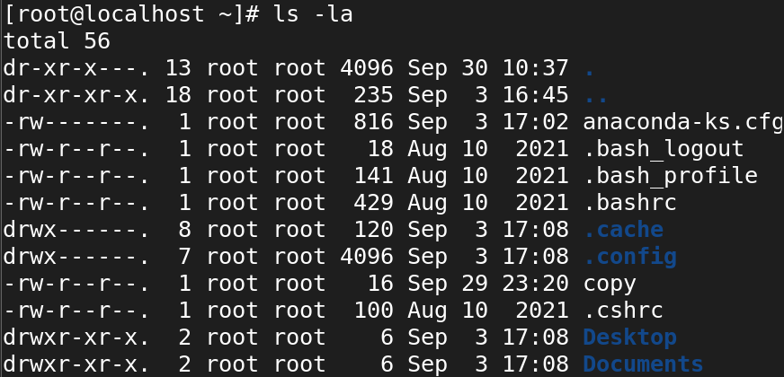

* Is it possible to list files and directories in a long format with human-readable file sizes?

Yes , it possible to list files and directories in a long format with human-readable file sizes by using command ls-lh 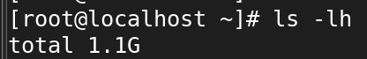

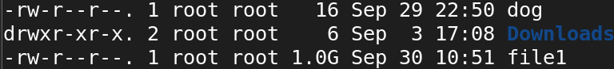

* How do I sort the ls output by different criteria, such as name, size, or modification time?

Bassically ls will show the alphebetic order (A-Z)

-t: Sort by modification time (newest first).

-S: Sort by size (largest first).

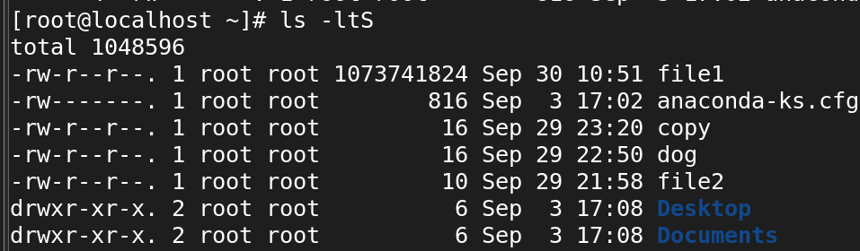

* Can ls display files and directories with color-coded output?

By default, the colors represent different types of files and directories:

* **Directories**: Blue
* **Executable files**: Green
* **Symbolic links**: Cyan
* **Compressed files**: Red
* **Block devices**: Yellow with black text
* **Sockets**: Magenta
* **Normal files**: Default terminal color

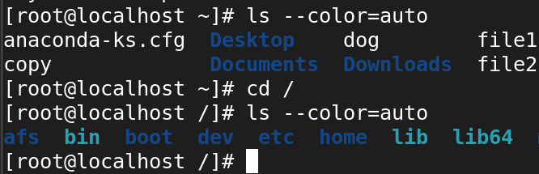

* How can I recursively list files and directories within sub-directories?

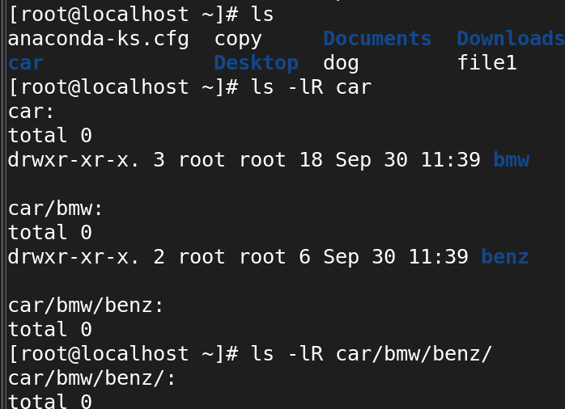

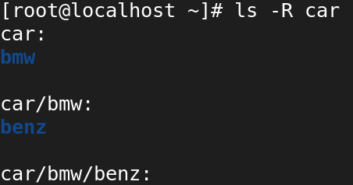

* What is the difference between ls and ls -l in terms of the information they display?



· It shows the **names** of files and directories.

· No details about file size, permissions, ownership, or modification time are shown.

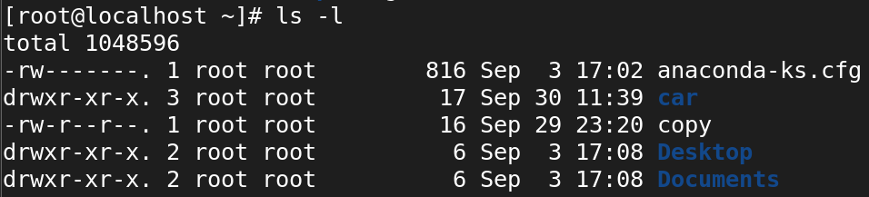

The ls -l command provides a **detailed long listing format**. It displays additional information about each file or directory, such as permissions, number of links, owner, group, size, and last modification time.

* How can I use ls to find files that match a specific pattern or extension?

· *: Matches zero or more characters.

· ?: Matches exactly one character.

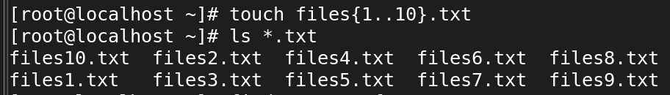

* Can ls display file sizes in units other than bytes, such as kilobytes or megabytes?

Yes

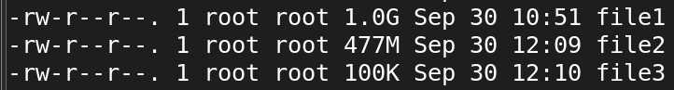

* How do I use ls to list only directories, excluding regular files?

Ls -ld */ is used to viwe only spific directory

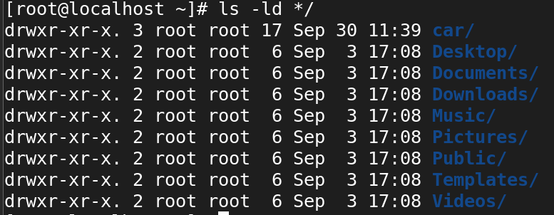

* What happens if I use ls with a directory that I don't have permission to access?

**4. Creating directories in Linux:**

* Which command is used to create a new directory in Linux?

# mkdir bike

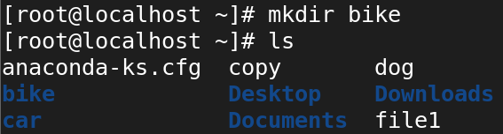

* What is the syntax for creating a directory using the mkdir command?

# mkdir (optional) dirctory_name

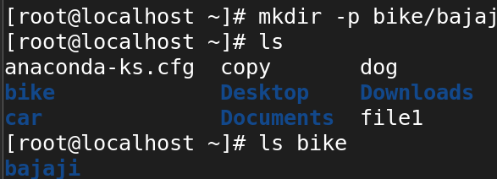

* Can you create multiple directories at once using the mkdir command? If yes, how?

Yes , we can create multiple dir at same time using mkdir command

# mkdir boy girl

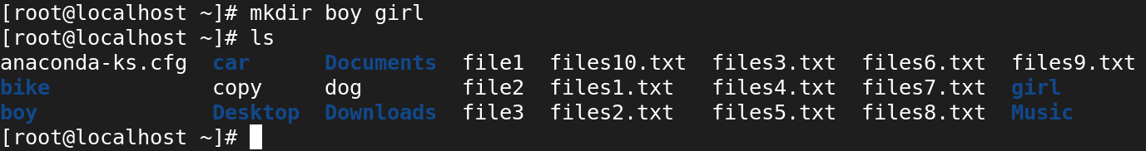

* How can you specify the full path for creating a directory in a specific location?

# mkdir /root/bike/bajaji/tvs

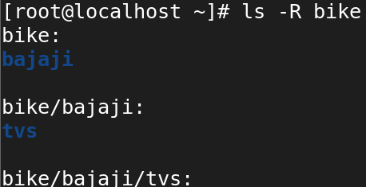

* What happens if you try to create a directory with a name that already exists in the current location? 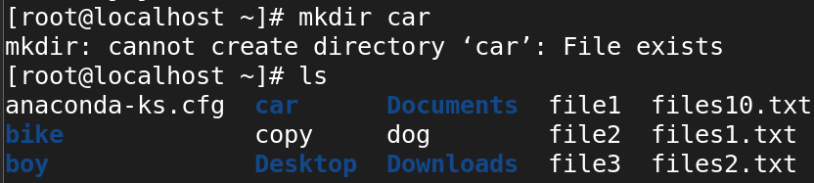
* Is it possible to create a directory with a space in its name? If yes, how?

Yes, it is possible to create a directory with a space in its name using the mkdir command in Linux.

You can create directories with spaces in their names using:

* **Quotation Marks**: mkdir "My Directory" or mkdir 'My Directory'
* **Backslashes**: mkdir My\ Directory

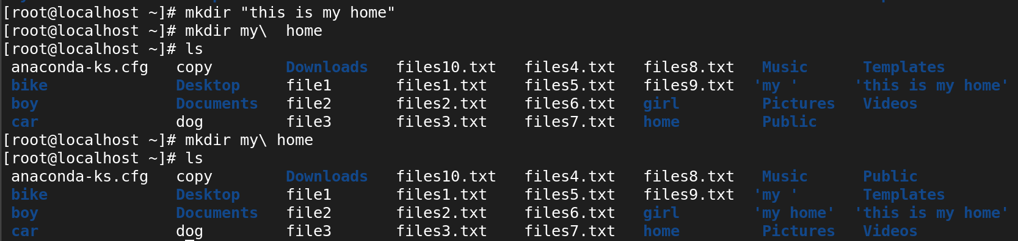

* How can you verify that a directory has been successfully created?

· Use ls or ls -l to list directories and verify its existence.

· Use find to search for the directory if you don’t know its location.

· Use stat to get detailed information about the directory.

· Use cd to attempt to change into the directory, verifying its existence by successfully entering it.

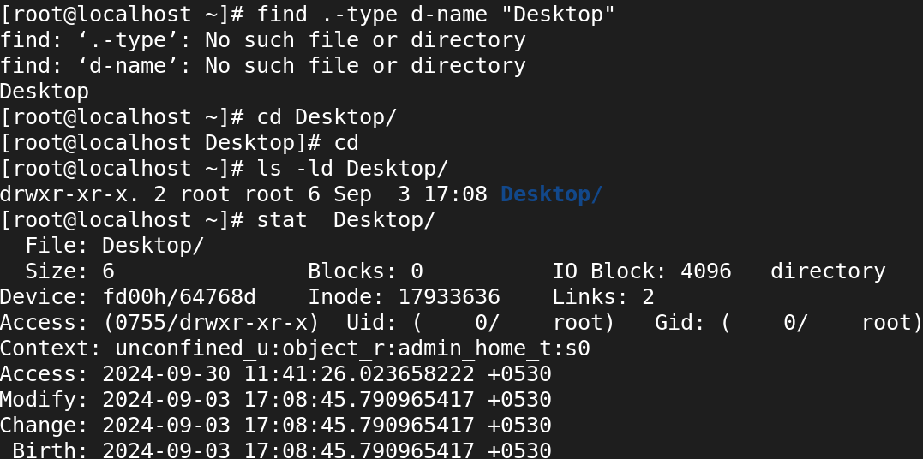

* Is there a way to create directories with specific permissions using the mkdir command?

Yes we can create by using command # mkdir -m (permission) (dir name)

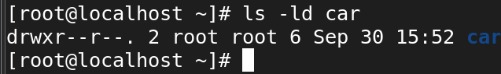

* How can you create nested directories (directories within directories) using the mkdir command?

# mkdir -p car/audi/bmw

-p --> refer to parent directory

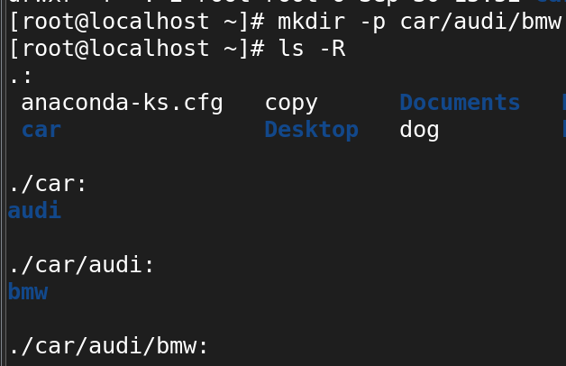

* Can you create a directory with a relative path instead of an absolute path? If yes, how?

Yes , Relative Paths: Use relative paths to create directories based on your current working directory.

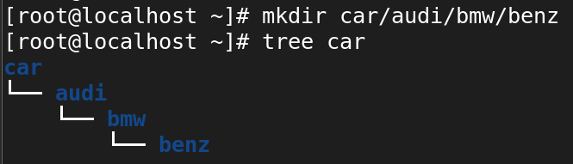

1. **copy (cp), move (mv), and remove (rm) commands for files and directories in Linux:**

**Copy (cp):**

* How do I copy a file to a different directory using the cp command?

#cp <source_file> <destination_file> 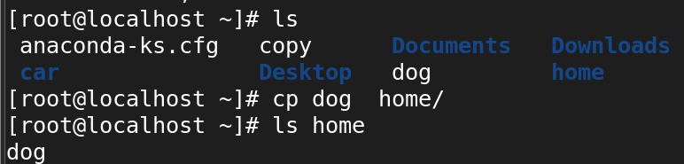

* Can I preserve the original file permissions when copying with cp?

· Use cp -p to preserve file permissions, timestamps, and ownership when copying files.

* For directories, combine -p with -R to preserve attributes during a recursive copy.

# cp - p sourcepath desitionpath

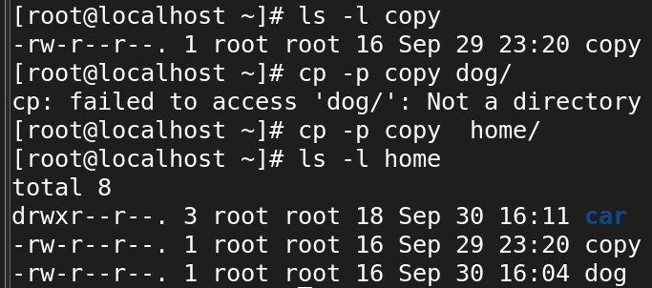

* How can I copy multiple files at once using the cp command?

# cp file1 file2 Download/

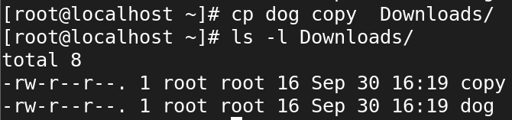

* Is it possible to overwrite an existing file when copying with cp?
* How can I copy a directory and its contents using cp?

By using command

# cp -r source destion

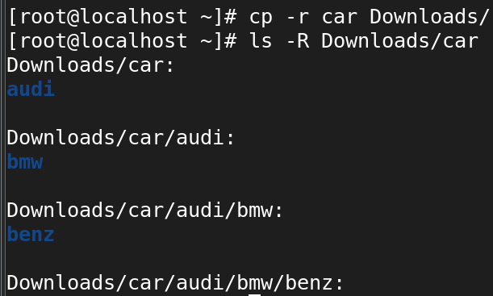

**Move (mv):**

* How do I move a file to a different directory using the mv command?

# mv source destination

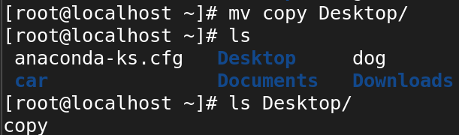

* Can I rename a file while moving it with the mv command?

Yes , we can rename it by using command.

# mv oldname newname

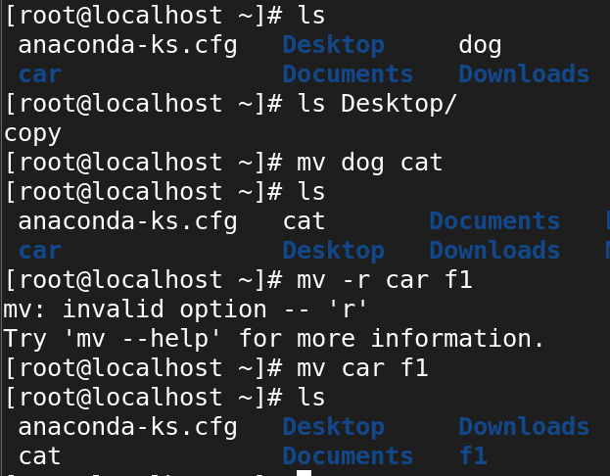

* What happens if I move a file to a directory where a file with the same name already exists?

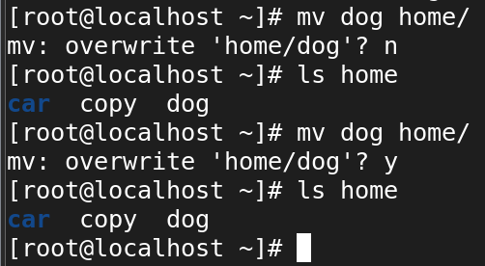

* How can I move multiple files at once using the mv command?

# mv file1 file2 folder/

# mv file* folder/

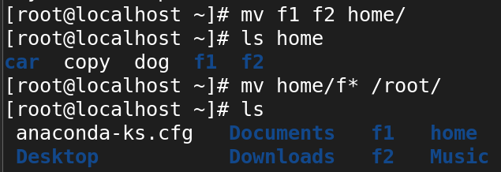

* Is it possible to move a directory and its contents using mv?

Yes it is possible by using command

# mv source dir desit dir

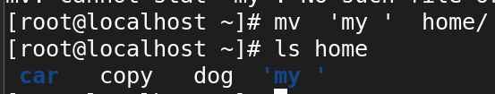

**Remove (rm):**

* How do I remove a file using the rm command?

# rm -f file name

# rm file name

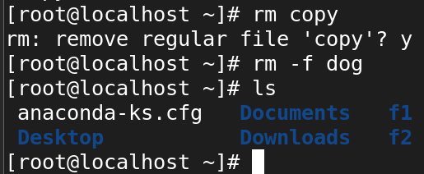

* Can I remove multiple files at once using the rm command?

Yes, # rm -f file1 file2

# rm -f file*

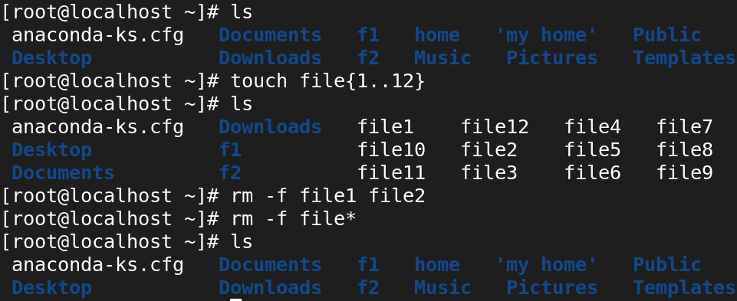

* How can I remove a directory and its contents using the rm command?

We should use command #rm -rf

1. -recrussively
2. -forcefully

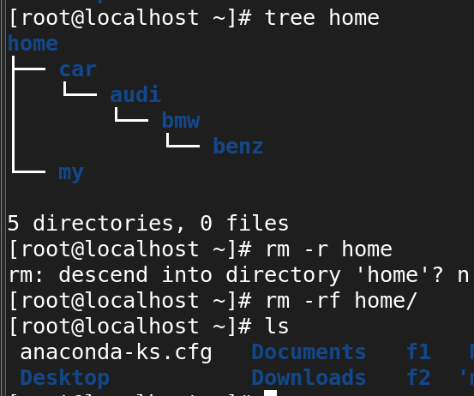

* What happens if I try to remove a file that is write-protected or has special permissions?

* Is there a way to force the removal of files or directories using rm?

· Use rm -f to forcefully remove files without prompts, ignoring write-protection.

· Use rm -rf to recursively and forcefully remove directories and their contents.

· Be cautious with these commands, as they can permanently delete data without confirmation.

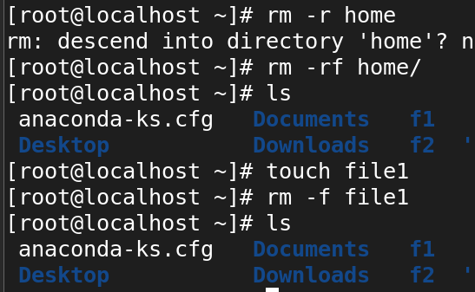

**6. File & Dir permissions**

* Here are some sample questions to test your knowledge of file and directory permissions in Linux:

* What are the three basic permissions for a file in Linux?

· **Read (r)**:

* Allows a user to **view or read** the contents of a file.
* For directories, the read permission allows a user to **list the contents** of the directory.

· **Write (w)**:

* Allows a user to **modify or edit** the contents of a file.
* For directories, the write permission allows a user to **add, delete, or rename files** within the directory.

· **Execute (x)**:

* Allows a user to **execute** a file, if it's a script or a program.
* For directories, the execute permission allows a user to **enter the directory** (using cd) and access its contents.
* How are file permissions represented in the output of the ls -l command?

**File type**: - (regular file)

· **Owner (user) permissions**: rwx (read, write, and execute)

· **Group permissions**: r-x (read and execute, but no write)

· **Others (world) permissions**: r-- (read-only)

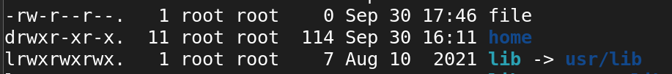

* What does the "r" permission indicate for a file? What about the "w" and "x" permissions?

· **Read (r)**: View contents (list directory contents).

· **Write (w)**: Modify contents (add, delete files in a directory).

· **Execute (x)**: Run files (enter or access directories).

* How can you change the permissions of a file using the chmod command?

# chmod (permission) < file OR dirc >

Chmod defines change modification

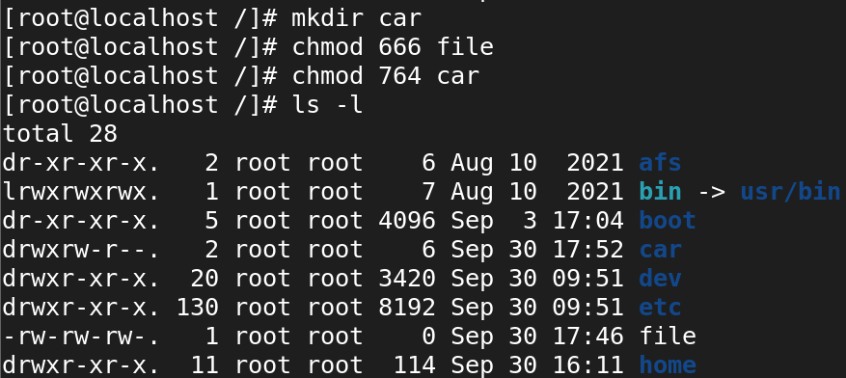

* What does the numeric representation 644 mean in terms of file permissions?

6 --> the owner can read and write the file

1. -> the group can only read

4 --> the others also only can read the file

* How can you change the permissions of a directory in Linux?

# Chmod (perm value) <direc name>

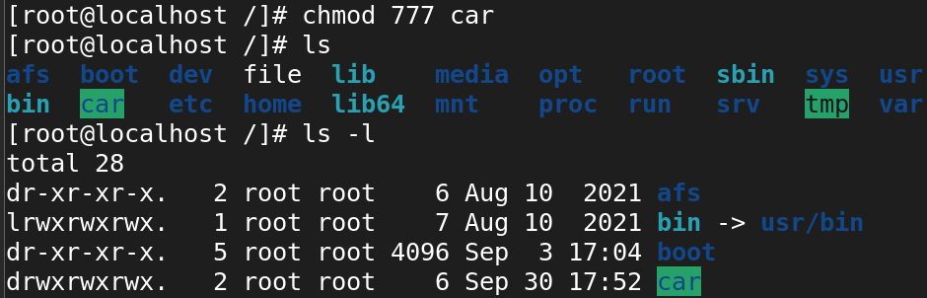

* What does the "x" permission mean for a directory?

X --> is used in change directory (cd)

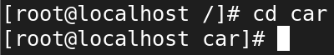

* How do you recursively change the permissions of all files and directories within a directory?

Use chmod -R to change permissions recursively.

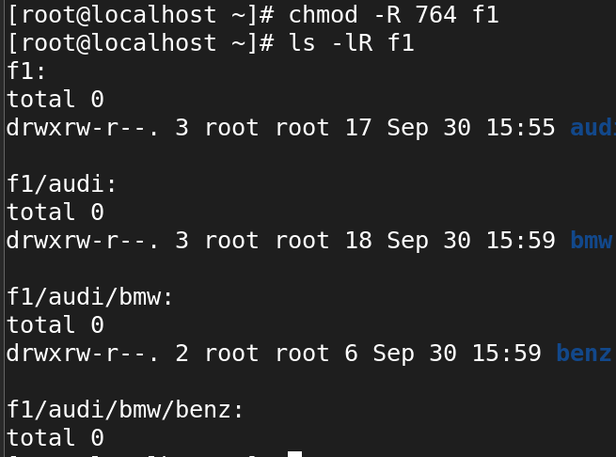

* What is the difference between the chmod command and the chown command?

Chmod is used to set permission value for file and directory

# chmod (permission value) <file OR directory>

# chown (owner name) : (group name) <directory name>

Chown is used to change ownership for owner and group

* How can you check the permissions of a directory using the ls command?

By using command ls -l

ls -ld */

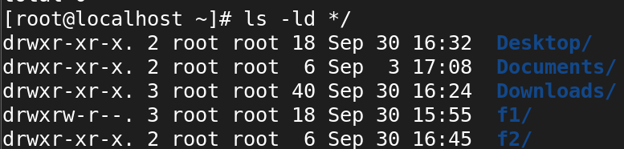

**7. Vi editor in Linux:**

* What is the purpose of the Vi editor in Linux?

It can used to edit the content of the file

· **Modal Editing**: Vi operates in different modes, primarily:

* **Normal Mode**: For navigation and command execution.
* **Insert Mode**: For entering text.
* **Command-Line Mode**: For executing commands (saving, quitting, etc.).

· **Efficient Navigation**: Vi allows users to navigate through text files quickly using keyboard shortcuts, making it suitable for programming and configuration file editing.

· **Powerful Editing Features**: It provides advanced editing capabilities, including:

* Text manipulation (copying, pasting, deleting).
* Search and replace functions.
* Undo and redo capabilities.
* What is the command to open a file in Vi for editing?

# vi file1

**vi:** This invokes the Vi editor

**filename:** This is the name of the file you want to edit. If the file does not exist, Vi will create a new file with that name when you save your changes.

* How do you switch to insert mode in Vi to start adding or modifying text?



Press I to switch vi to insert mode.

* How do you save changes and exit Vi?

:wq ---w is used to save and q is used for quite

:x ---x is used for save and exit

:wq! ---it used for save and exit ! used forcefully

* What is the command to exit Vi without saving changes?

:q ---used exit without saveing

:q ! ----used to exit forcefully without saving

* How can you move the cursor to the beginning and end of a line in Vi?

I --> it is used move the cursor at the beginning of the line

A --> it is used move the cursor at the end of the line

Both or used for move from vi to insert mode.

* What is the command to search for a specific word or pattern in Vi?

· Enter Normal Mode: Press Esc to ensure you are in Normal mode.

· Type the Search Command: Use the / followed by the word or pattern you want to search for

/ case should type in command mode



* How can you delete a character or a line in Vi?

· x: Delete a single character.

· dd: Delete the entire current line.

· 5dd: Delete 5 lines starting from the current line.

· dw: Delete a word.

* How do you copy and paste text in Vi?
* yy: Copy (yank) the current line.
* 3yy: Copy 3 lines.
* yw: Copy the current word
* p: Paste after the cursor or line.
* P: Paste before the cursor or line.
* What are some basic navigation commands in Vi to move between different sections of a file?
* · **h**/**j**/**k**/**l:** Move left, down, up, right by one character.
* **w**/**b**/**e:** Move by words (forward, backward, to the end of the word).
* ·  **0**/$**:** Move to the beginning/end of the line.
* · **gg**/**G:** Move to the beginning/end of the file.
* · **:linenumber:** Move to a specific line.
* · **Ctrl+f**/**Ctrl+b:** Scroll forward/backward by a page.
* How do you search for a specific word or phrase in Vi?

· **/word_or_phrase:** Search for a word or phrase forward in the file.

· **?word_or_phrase:** Search for a word or phrase backward in the file.

·  **n:** Jump to the next match.

·  **N:** Jump to the previous match.

* What is the difference between the :w and :wq commands in Vi?

W --> used for save changes.

Wq --> used for save and exicute.

* How do you delete a single character in normal mode?

1. Ensure you are in **Normal mode** by pressing Esc.
2. Place the cursor on the character you want to delete.
3. Press x.

**8. Special permissions in Linux:**

* What are the three special permissions in Linux?

Types of Special permissions

1.Setuid (SUID) - 4

2.Setgid (SGID) - 2

3.Stickybit - 1

* What is the purpose of the setuid permission?

The purpose of setuid is to acess all root previlage command by an normal user is called an setuid.

· setuid allows users to execute a file with the file owner’s privileges.

· It’s typically used for system commands where normal users need elevated permissions for specific tasks (e.g., changing a password).

* How is the setuid permission represented in the output of the ls -l command?

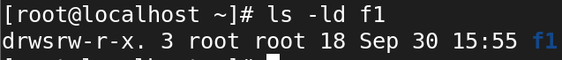

rws: setuid bit is set, and the owner has execute permission.

rwS: setuid bit is set, but the owner does not have execute permission (unusual).

* What is the effect of the setuid permission on an executable file?

1. When a user runs an executable file that has the setuid bit set, the program runs with the file owner's privileges rather than the privileges of the user executing the file.
2. If the file is owned by root and has the setuid bit set, then the program will execute with root privileges even if it is run by a regular user.
3. The /bin/passwd program, used for changing user passwords, is owned by root and has the setuid bit set. When a normal user runs passwd, the program modifies the system’s password file, which is normally only writable by root. Because of the setuid permission, the program runs with root privileges, allowing the user to change their password without having full root access.

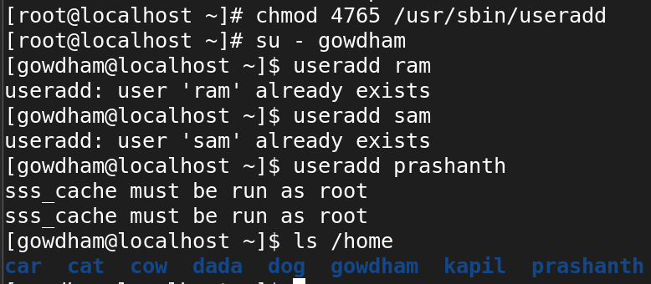

* What is the purpose of the setgid permission?

· On Files: When a file has the setgid bit set, the file, when executed, runs with the permissions of the file’s group owner, rather than the group of the user executing the file.

· On Directories: When a directory has the setgid bit set, any files or subdirectories created inside that directory inherit the group ownership of the directory, rather than the default group of the user who created the file.

If you setup SGID on directores, all files or directories created inside that directory will be owned by the same common group(group owner of the directory where SGID is configured).

The SetGID permission displays as an “s” in the group executable field. Its numeric value is 2.

**chmod 2755 <file/dirname>**

* How is the setgid permission represented in the output of the ls -l command?

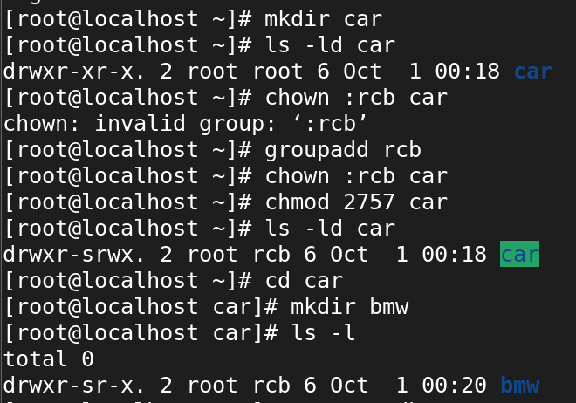

* What is the effect of the setgid permission on a directory?

1. Inherited Group Ownership: New files and subdirectories inside the directory will inherit the directory’s group ownership, not the user’s default group.
2. Collaboration: Facilitates group collaboration by ensuring consistent group ownership of files.
3. The setgid (Set Group ID) permission on a directory has a specific effect that alters the behavior of group ownership for files and subdirectories created within that directory.

* What is the purpose of the sticky bit permission?

The sticky bit is a special permission in Linux that is used primarily on directories to restrict the deletion or renaming of files within that directory. When the sticky bit is set, only the owner of the file, the owner of the directory, or the root user can delete or rename files within that directory, even if other users have write permissions.

**Purpose of the Sticky Bit:**

The sticky bit is used to protect files in a shared directory. It ensures that users cannot delete or rename each other’s files, even if they have write permissions to the directory.

* How is the sticky bit permission represented in the output of the ls -l command?

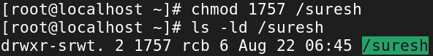

* What is the significance of the sticky bit on a directory?

· Prevents non-owners from deleting or renaming files in a directory, even if they have write permissions.

· Ensures file protection in shared directories where multiple users have access.

· Commonly applied to directories like /tmp and shared workspaces to prevent unauthorized file deletion.

**9. User and Group administration in Linux:**

* What is the command to create a new user in Linux?

# Useradd (username)

# adduser (username)

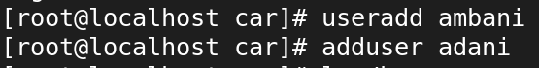

* How can you specify a user's home directory during user creation?

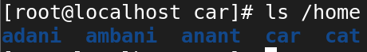

* How do you assign a password to a user account in Linux?

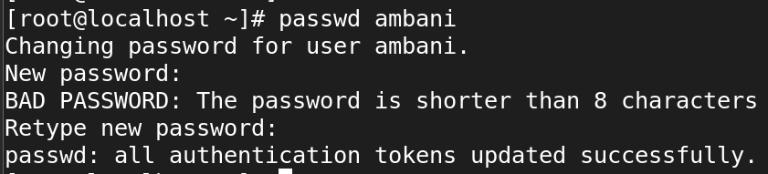

* What command is used to delete a user from the system?

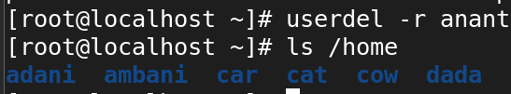

* How can you add an existing user to a specific group?



* What command is used to create a new group in Linux?

# groupadd (groupname)



* How do you add a user to a newly created group?

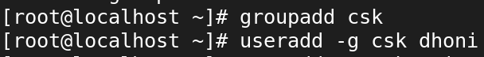

* What is the purpose of the chgrp command?

· **Purpose**: Change the group ownership of files or directories.

· **Syntax**: chgrp groupname filename

· **Common Use**: In multi-user environments where group access to files is needed.

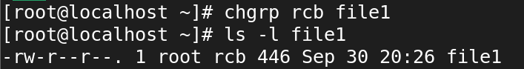

* How can you list all the users on a Linux system?

# cat /etc/passwd

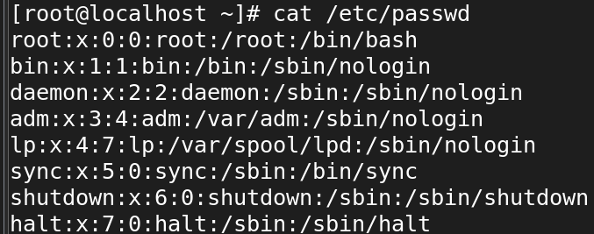

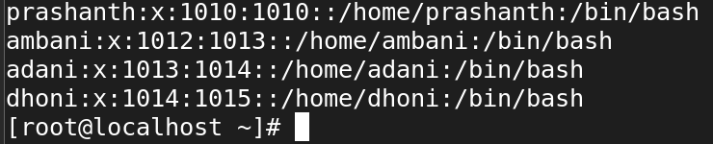

* What command can you use to modify a user's account settings, such as their shell or home directory?

To modify a user's account settings, such as their shell or home directory, you can use the usermod command in Linux. This command allows you to change various attributes of a user account.

usermod [options] username



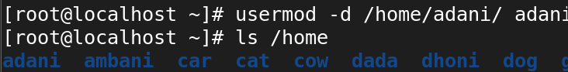

* How do you list all the users on a Linux system?

# cat /etc/passwd





* What command is used to add a new user in Linux?

# useradd <username>

# adduser <username>

* How can you assign a user to a specific group during user creation?

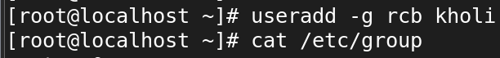

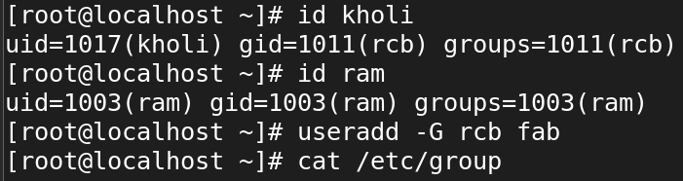



* What is the purpose of the usermod command?

Usermod is used to modify in userdetail.

The usermod command in Linux is used to modify an existing user account's settings and attributes. It allows system administrators to change various properties associated with user accounts without having to delete and recreate them.

* How do you change a user's password in Linux?

# passwd username

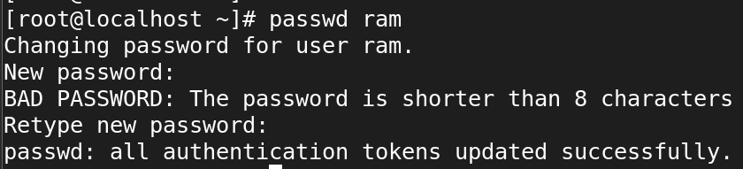

* How do you lock or unlock a user account using the passwd command?

# passwd -l <username> ---->it used to lock user acc

# passwd -u <username> -----> it used to unlock user acc

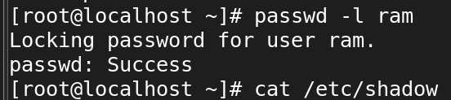



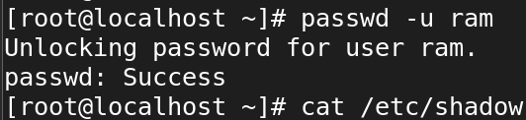



* What is the purpose of the groupadd command?

Purpose of the groupadd Command:

**Create New Groups**: It establishes a new group with a specified name, enabling organization of users with similar roles or permissions.

**Manage Permissions**: By grouping users, administrators can easily assign and manage permissions for multiple users at once.

**Control Access**: Groups help control access to shared resources, such as files and directories, based on group membership.

* How do you add an existing user to an existing group?



* How can you remove a user from a group?

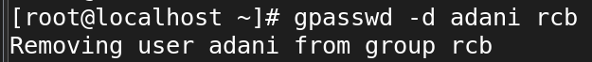

* What command is used to delete a user account in Linux?

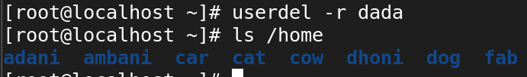

* How do you display the details of a specific user, including their group memberships and other information?

to display the details of a specific user in Linux, including their group memberships and other information, you can use the id and getent commands, as well as view the /etc/passwd 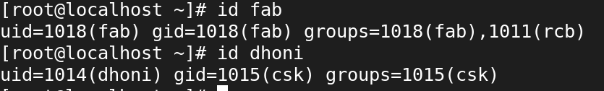

* How can you create a new group and set its GID (Group ID) using the groupadd command?

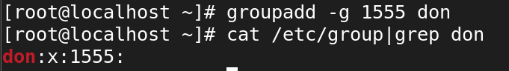

* What is the difference between the useradd and adduser commands?

Useradd:-

· Requires specific options to be provided for common settings (like home directory, shell, etc.).

· Does not prompt for additional information, so users need to know the command syntax and options.

This is a low-level command that is part of the standard Linux user management commands

Adduser:-

· Interactively prompts for user details such as password, home directory, and other settings.

· Offers a more user-friendly approach, which can be especially helpful for less experienced users.

. It usually provides a guided process with prompts for additional user information.

* How can you list all the groups on a Linux system?

# cat /etc/group

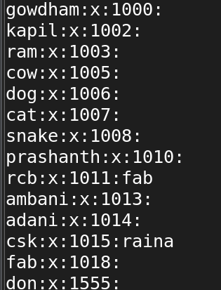

* What is the purpose of the /etc/passwd file in Linux?

` it is used to see all users information and detail

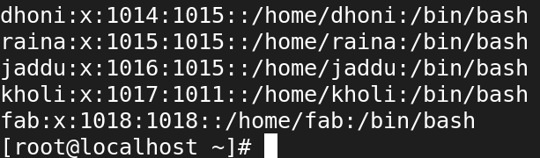

* What information does each line in the /etc/passwd file represent?

**/etc/passwd -** Username: User's password mask : UID : GID : User Comment : home directory of user: Default log-in shell



* How can you view the contents of the /etc/passwd file?

# cat /etc/passwd **Using cat:** The cat command displays the entire content of the file at once.

You can scroll up and down using the arrow keys in less, while more only allows forward navigation.

# less /etc/passwd

# more /etc/passwd

# head /etc/passwd **Using head**: The head command shows only the first 10 lines by default.

#tail /etc/passwd ****Using** tail:** The tail command shows the last 10 lines by default.

#grep username /etc/passwd **Using grep**: You can use grep to search for specific user entries in the file.

* What is the purpose of the /etc/shadow file?

It is used to show user passwd information

· The /etc/shadow file is only accessible to root or superuser to protect sensitive data.

· Passwords are encrypted, enhancing security by preventing plain-text passwords from being easily compromised.

· It includes password aging policies, helping enforce security by requiring users to update their passwords regularly.

* How is the /etc/shadow file different from the /etc/passwd file?

/etc/passwd ---> it show the all user full detail and information

/etc/sadow ---> it show the user encrepted paswd information

* How can you view the contents of the /etc/shadow file?

# cat /etc/shadow **Using cat:** The cat command displays the entire content of the file at once.

You can scroll up and down using the arrow keys in less, while more only allows forward navigation.

# less /etc/shadow

# more /etc/shadow

# head /etc/shadow **Using head:** The head command shows only the first 10 lines by default.

#tail /etc/shadow ****Using** tail**: The tail command shows the last 10 lines by default.

* What is the purpose of the /etc/gshadow file?

The /etc/gshadow file in Linux stores group password information and related group security settings.

It is the shadow counterpart to the /etc/group file, and its primary purpose is to enhance group security by securely storing encrypted group passwords and controlling administrative access to groups

It defines group administrators who can modify group membership and security settings.

* How is the /etc/gshadow file different from the /etc/group file?

| **Aspect** | /etc/gshadow | /etc/group |
| --- | --- | --- |

|  |  |  |
| --- | --- | --- |
| **Purpose** | Stores **encrypted group passwords** and group-related security information. | Contains basic group information like group names, GIDs, and group memberships. |

|  |  |  |
| --- | --- | --- |
| **Password Storage** | Stores the **encrypted password** for a group (if it exists). | Does **not store any passwords**; only basic group info. |

|  |  |  |
| --- | --- | --- |
| **Group Administrators** | Defines **group administrators** who can manage the group (add/remove members). | Does **not specify group administrators**. |

|  |  |  |
| --- | --- | --- |
| **Security** | **Sensitive file**, only accessible by the root user. | Readable by all users on the system. |

|  |  |  |
| --- | --- | --- |
| **Membership Management** | Defines both **group administrators** and **group members**. | Lists **group members** but has no provisions for group admins or passwords. |

|  |  |  |
| --- | --- | --- |
| **Permissions** | Only **root** can read and modify this file. | Readable by all users, but **only root** can modify it. |

* How can you view the contents of the /etc/gshadow file?

**/etc/gshadow -** Groupname:group password:group id admin:Members of group

* What is the purpose of the /etc/group file in Linux?

The /etc/group file in Linux stores information about the groups on the system. It serves to associate users with groups, allowing for easier management of permissions and access control. The file contains basic information like group names, group IDs (GIDs), and the list of users who belong to each group.

Stores Group Information: It stores the group name, group ID (GID), and the list of users in each group.

* How can you view the contents of the /etc/group file?

/etc/group - Groupname:password:GID:Members of group

* What information does each line in the /etc/group file represent ?

**developers:** The group name.

·  **x:** A placeholder.

· **1001:** The group ID (GID).

· **alice,bob,charlie**: Users who belong to the **developers** group.

* How can you add a new user to the /etc/passwd file and assign them to a group?

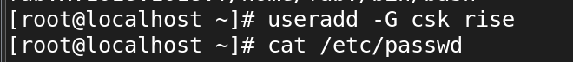



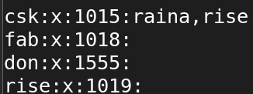

* How do you lock or disable a user account in the /etc/shadow file?

Passwd -l username ---> to lock

Passwd -u username ---> to unlock

* What command is used to modify user group memberships in the /etc/group file?

The usermod command is used to modify user group memberships in Linux, including updating the /etc/group file.

· usermod -G: Modifies user group memberships.

· usermod -a -G: Appends new groups to the user's current group memberships, ensuring that existing group memberships are retained.

**10. Processes in Linux:**

* What is a process in Linux?

An instance of a program is called a Process. In simple terms, any command that you give to your Linux machine starts a new process.

In Linux, a process is an instance of a running program. It is essentially an executing instance of a program or command. Each process is assigned a unique Process ID (PID) and is managed by the Linux kernel.

* How can you view the currently running processes In Linux?

To view the currently running processes in Linux, you can use several commands, each providing different levels of detail and interaction. The most commonly used commands are:

Ps ---> it used to print screen all running process

Ps -aux --->This shows the processes running in the current terminal session.

Top ---> this command is used to show all running in the terminal in live state.

* What command is used to start a new process in Linux?

Seq 100000000000 > /dev/null

The command used to start a new process in Linux is simply the name of the program or command you want to run. When you execute any command in the terminal, a new process is created to run that command.

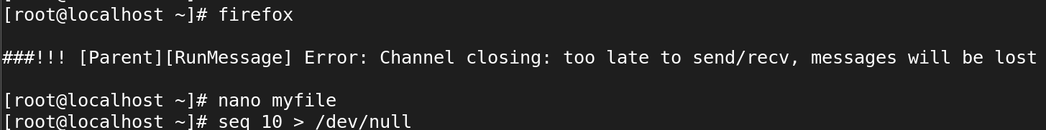

* How can you identify the process ID (PID) of a running process?

Ps , Ps -aux

Pidof bash

Pgrep top

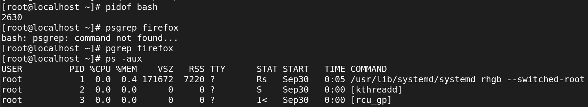

* What is the purpose of the ps command in Linux?

1. The ps (Process Status) command in Linux is used to display information about the currently running processes on the system.
2. It provides a snapshot of processes at the time the command is executed, listing details like the Process ID (PID), the user running the process, the amount of CPU and memory usage, and the command used to start the process.
3. The ps command in Linux is an essential tool for process management, providing a quick way to view, monitor, and interact with running processes, including their PIDs, resource usage, and user ownership

* How can you terminate a process in Linux?



* What is the difference between a foreground process and a background process?

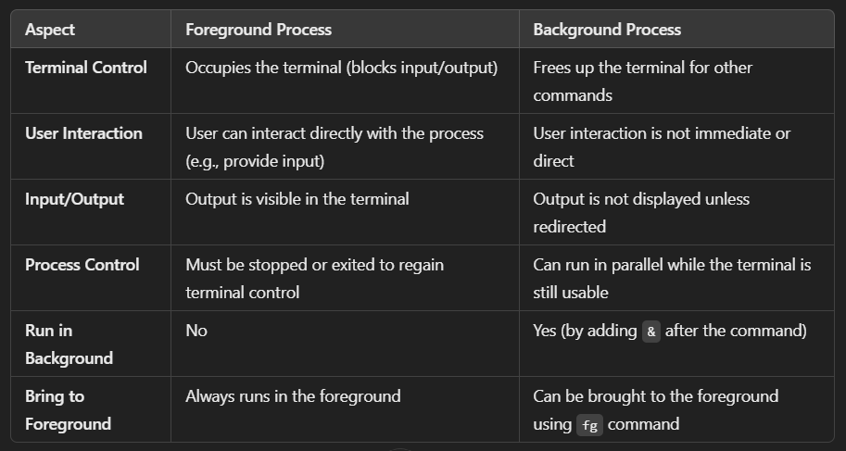

* How do you start a process in the background in Linux?

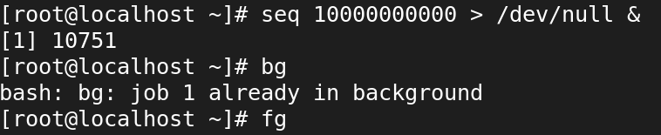

* How can you check the status of a specific process in Linux?

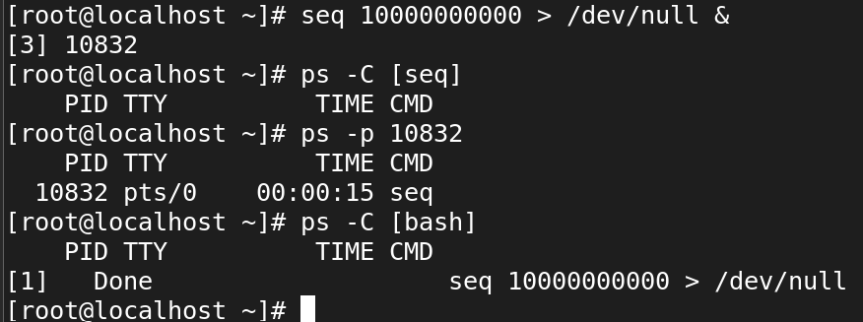

* What is a parent process and a child process in Linux?

**Parent process:**

In Linux all the processes have a parent process. When the user creates a process in that case the kernel process becomes the parent of that process.

Every Linux process has two ID's assigned to it, the Process ID (pid) and the Parent process ID (ppid).

**Child Processes:**

The processes which gets created by another process it'ns parent process known as child process.

* How can you change the priority of a process in Linux?

Every process have scheduling priorities.

The value which is assigned for scheduling the priorities is called "NICE VALUE" Nice value range is -­20 to 19

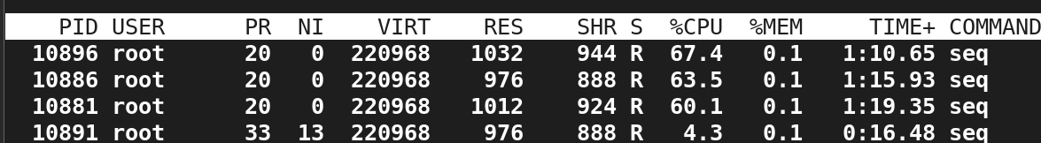

* What is the purpose of the top command in Linux?

The top command in Linux provides a real-time, dynamic view of system processes, displaying information such as CPU usage, memory usage, running tasks, and more. It's a powerful tool for monitoring system performance and identifying resource-hungry processes.

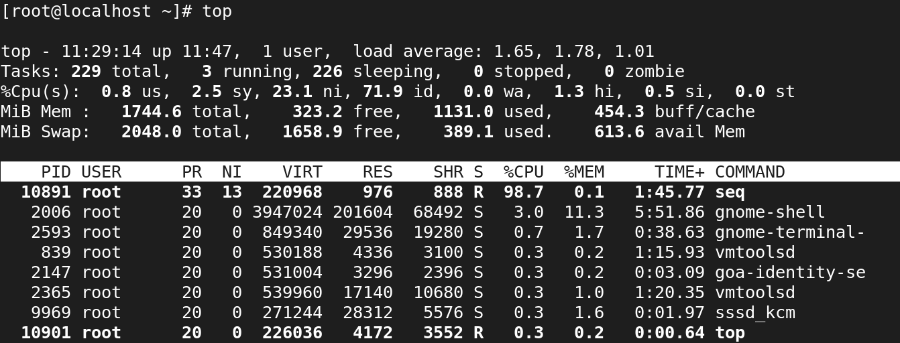

* How can you monitor the resource usage of a process in Linux?

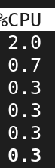 c ----> is used to see usage of cpu’s

* What is the significance of the process states, such as "Running," "Sleeping," and "Zombie"?

· **Running (**R**)**: The process is currently using CPU or ready to use it.

· **Sleeping (Interruptible** S**)**: Waiting for an event (e.g., input).

· **Sleeping (Uninterruptible** D**)**: Waiting for I/O and cannot be interrupted.

· **Stopped (**T**)**: The process has been stopped, either manually or by a signal.

· **Zombie (**Z**)**: The process has finished, but its exit status hasn't been read by the parent process.

* How can you send signals to a running process in Linux?

In Linux, signals are a way to communicate with running processes to instruct them to perform certain actions, such as terminating, stopping, or reloading their configuration. You can send signals to a running process using various commands like kill, pkill, and killall.

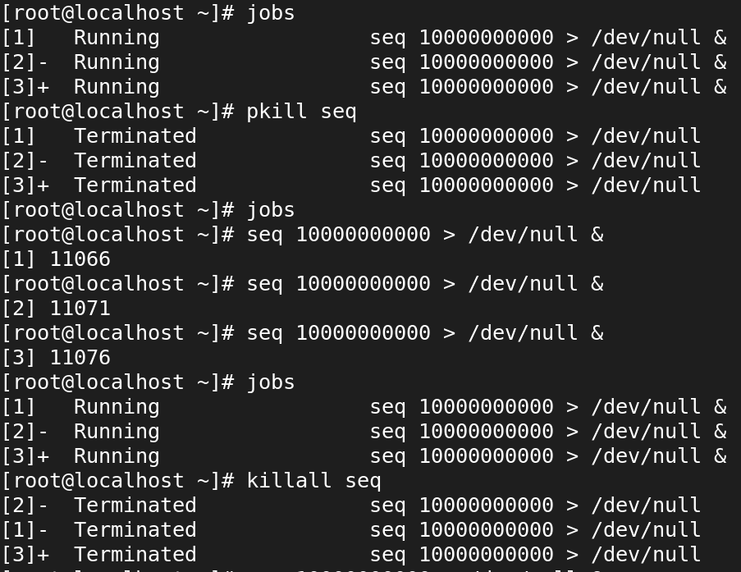

* How do I run the top command?

While top is running, you can use keyboard shortcuts to control and manipulate the display. Some common commands are:

k: Kill a process by entering its PID.

r: Renice a process by entering its PID and new priority value.

u: Display only processes owned by a specific user.

M: Sort the processes by memory usage.

P: Sort the processes by CPU usage.

q: Quit the top command.

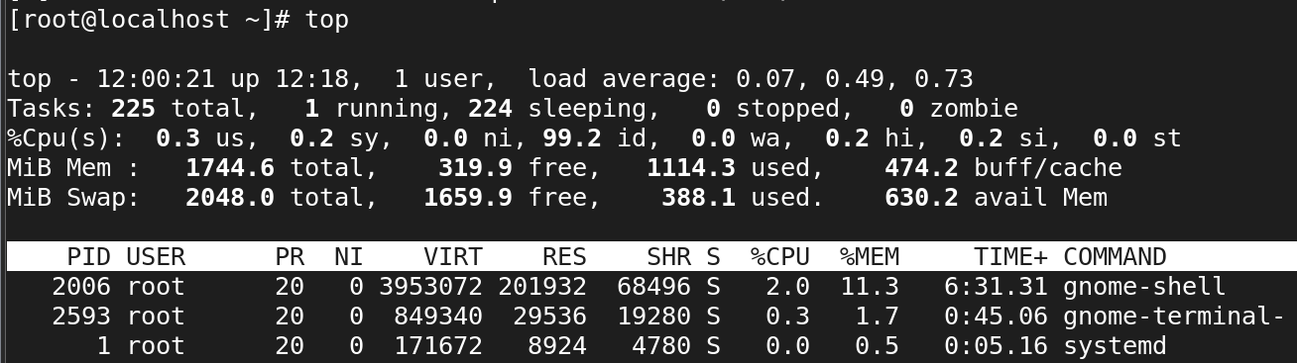

* What information does the top command display?

### top ****Display****

* **PID**: Process ID
* **USER**: The owner of the process
* **%CPU**: Percentage of CPU usage by the process
* **%MEM**: Percentage of memory usage by the process
* **TIME+**: Total CPU time used by the process
* **COMMAND**: The command that started the process
* How do I interpret the CPU usage information shown by top?

By entering c --command



· **us (user space)**: Percentage of CPU time spent on user processes (non-kernel).

· **sy (system space)**: Percentage of CPU time spent on system (kernel) processes.

· **ni (nice)**: Percentage of CPU time spent on processes with altered priority (nice values).

· **id (idle)**: Percentage of CPU time spent in idle state (not used).

· **wa (I/O wait)**: Percentage of CPU time spent waiting for I/O operations to complete.

· **hi (hardware interrupts)**: Percentage of CPU time spent servicing hardware interrupts.

· **si (software interrupts)**: Percentage of CPU time spent servicing software interrupts.

· **st (steal time)**: Percentage of CPU time taken from a virtual machine by the hypervisor

* How can I sort processes based on different criteria (e.g., CPU usage, memory usage) in top?

First enter top command

· **P**: %CPU (CPU usage)

· **M**: %MEM (Memory usage)

· **N**: PID (Process ID)

· **T**: TIME+ (Total CPU time)

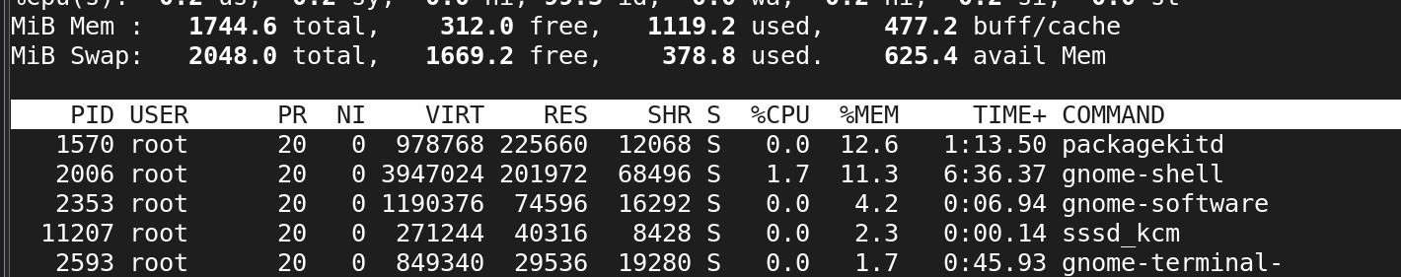 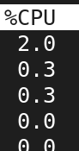

* Is it possible to change the update frequency of top to see real-time changes more or less frequently?

Yes, it is possible to change the update frequency of the top command to see real-time changes more or less frequently. By default, top refreshes its output every **3 seconds**, but you can adjust this interval. The below top command will update in every 5sec 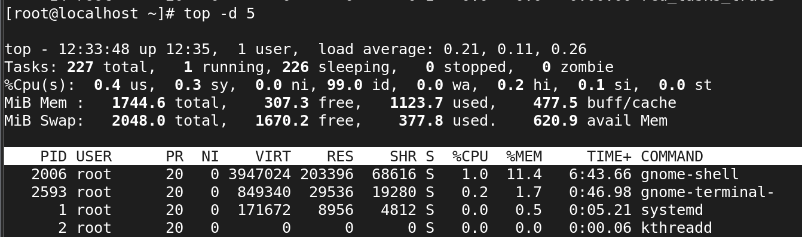

* How can I view only the processes of a specific user with top?

# top -u username

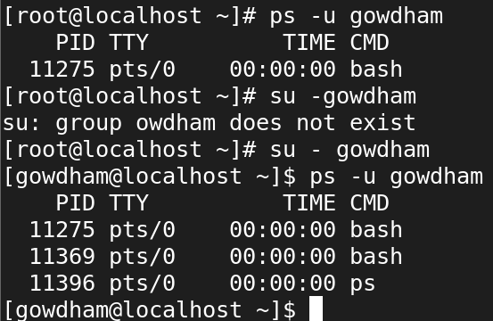

* What are the basic navigation keys in top for sorting and filtering processes?

· **Sorting Processes**:

* **P**: Sort by CPU usage (default).
* **M**: Sort by memory usage (RES).
* **N**: Sort by process ID (PID).
* **T**: Sort by running time (TIME+).
* **S**: Sort by priority (PRI).

· **Filtering Processes**:

* **u**: Filter processes by a specific user.
  + After pressing **u**, enter the username to see only that user’s processes.
* **O**: Sort by a specific field (interactive).
  + Press **Shift + O** to choose a field to sort.
* Can top show the full command line used for each process?
* How do I kill a process directly from top?

Press k to kill process and give pid and kill using -9

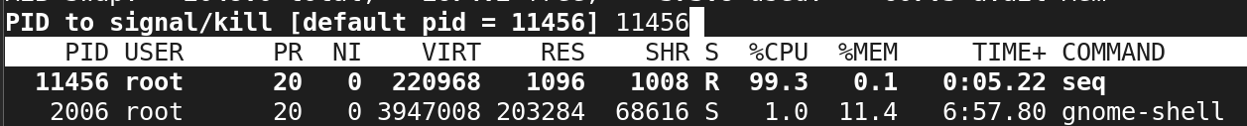

* Can top show the overall memory and CPU usage summary for the system?

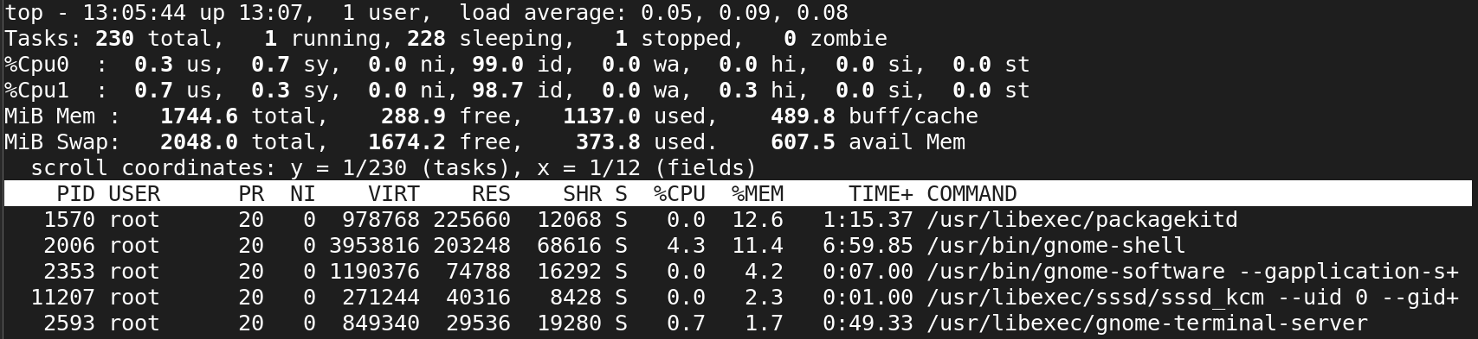

* Is there a way to display the top output in a non-interactive mode (e.g., for scripting purposes)?

* What do the different colors and flags represent in the top output?

Shift +z is used change colour

Z is show default colour 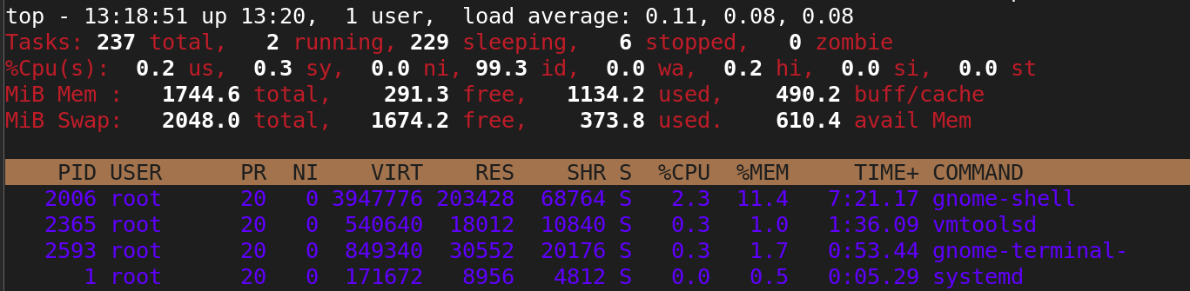

* How can I adjust the priority of a process using top?

Every process have scheduling priorities.

The value which is assigned for scheduling the priorities is called "NICE VALUE" Nice value range is -­20 to 19



* Are there alternative commands or utilities similar to top for monitoring system performance?

Htop , Atop , glance , nmon , dstat , iostat ,mpstat,

The above all command first install and use it



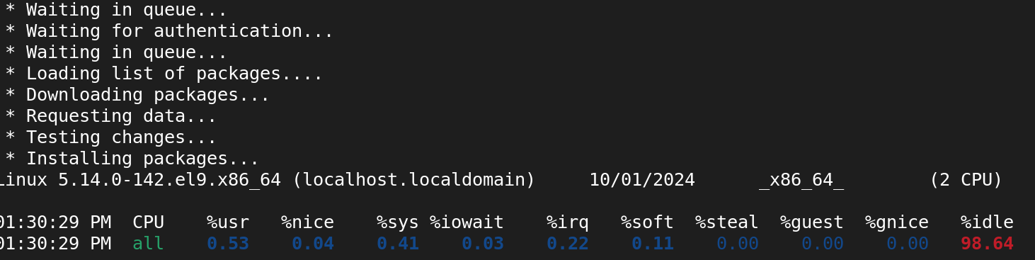

* How can I save the top output to a file for later analysis?
* How can you terminate a process in Linux?

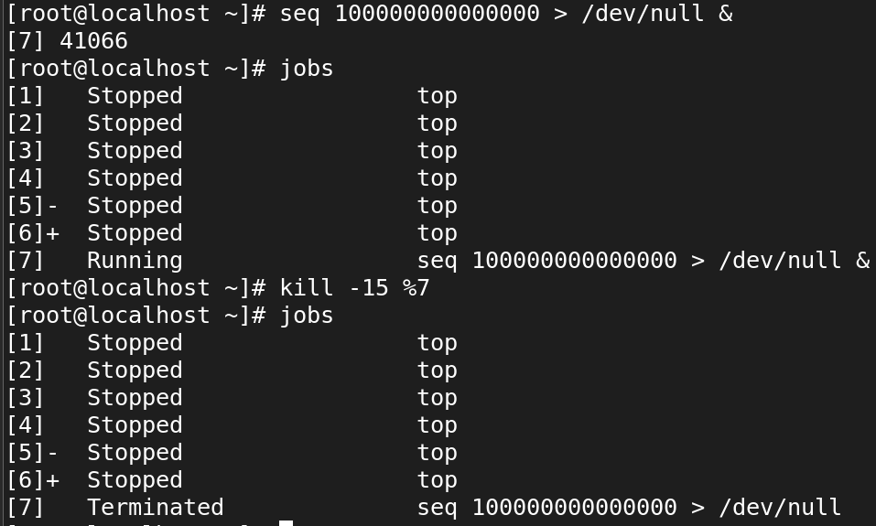

* What is the difference between a foreground process and a background process?



* How do you start a process in the background in Linux? 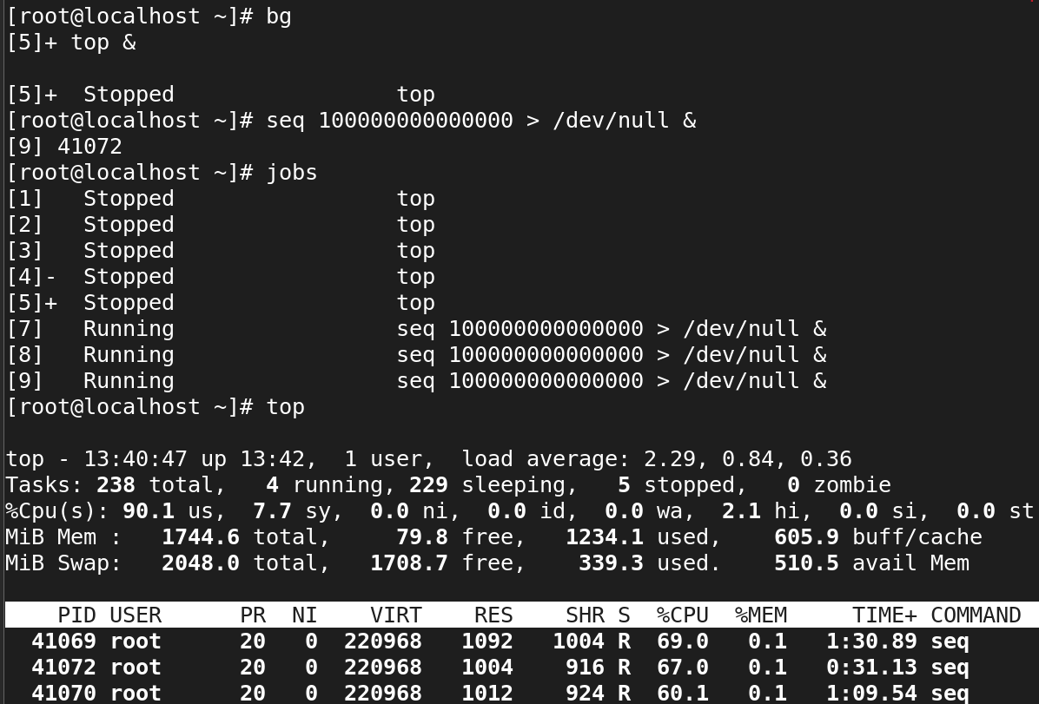
* How can you check the status of a specific process in Linux?



* What is a parent process and a child process in Linux?

**Parent process:**

In Linux all the processes have a parent process. When the user creates a process in that case the kernel process becomes the parent of that process. Every Linux process has two ID's assigned to it, the Process ID (pid) and the Parent process ID (ppid).

**Child Processes:**

The processes which gets created by another process it'ns parent process known as child process.

* How can you change the priority of a process in Linux?

Every process have scheduling priorities.

The value which is assigned for scheduling the priorities is called "NICE VALUE" Nice value range is -­20 to 19

Fitst enter top command and enter r to renice value antd enter pid value and set now priority value.



* What is the purpose of the top command in Linux?

The top command in Linux provides a real-time, dynamic view of system processes, displaying information such as CPU usage, memory usage, running tasks, and more. It's a powerful tool for monitoring system performance and identifying resource-hungry processes.



* How can you monitor the resource usage of a process in Linux?

you can monitor the resource usage of a process in Linux using various commands and tools, such as top, htop, ps, pidstat, vmstat, pmap, nmon, and systemd-cgtop. Each tool has its own strengths, so you can choose one based on your specific monitoring needs

.

* What is the significance of the process states, such as "Running," "Sleeping," and "Zombie"?

· **Running (**R**)**: The process is currently using CPU or ready to use it.

· **Sleeping (Interruptible** S**)**: Waiting for an event (e.g., input).

· **Sleeping (Uninterruptible** D**)**: Waiting for I/O and cannot be interrupted.

· **Stopped (**T**)**: The process has been stopped, either manually or by a signal.

· **Zombie (**Z**)**: The process has finished, but its exit status hasn't been read by the parent process.

* How can you send signals to a running process in Linux?

In Linux, signals are a way to communicate with running processes to instruct them to perform certain actions, such as terminating, stopping, or reloading their configuration. You can send signals to a running process using various commands like kill, pkill, and killall.



**11. Services in Linux:**

* What is a service in the context of Linux?

In the context of Linux, a **service** is a background process that runs without direct user interaction and performs a specific task or set of tasks.

These services are typically started automatically at boot time and continue running until the system is shut down or the service is stopped.

* How can you check the status of a service in Linux?

· For **systemd**-based systems, use **systemctl status <service-name>.**

· For older **SysVinit** systems, use **service <service-name> status.**

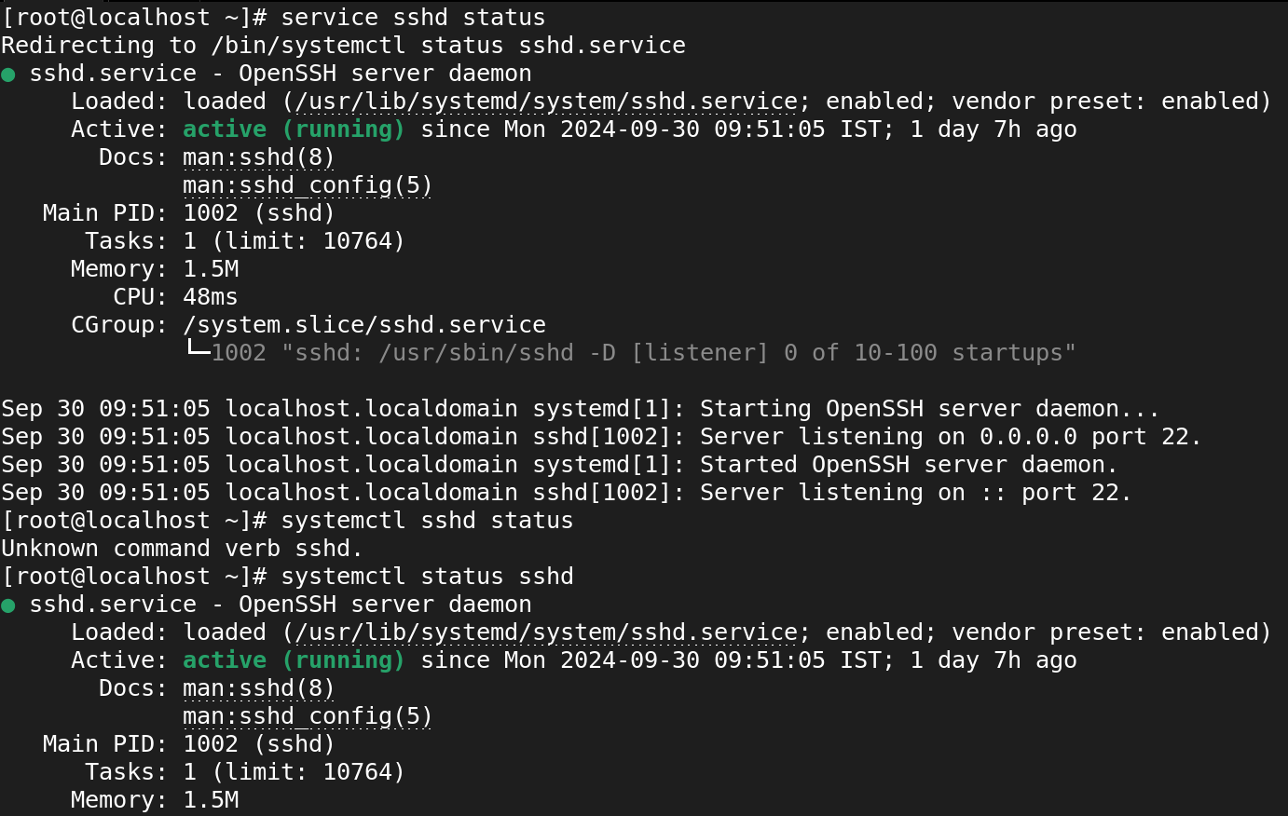

* What command is used to start a service in Linux?
* For **systemd** systems, use **systemctl start <service-name>.**
* For older **SysVinit** systems,  **use service <service-name> start**

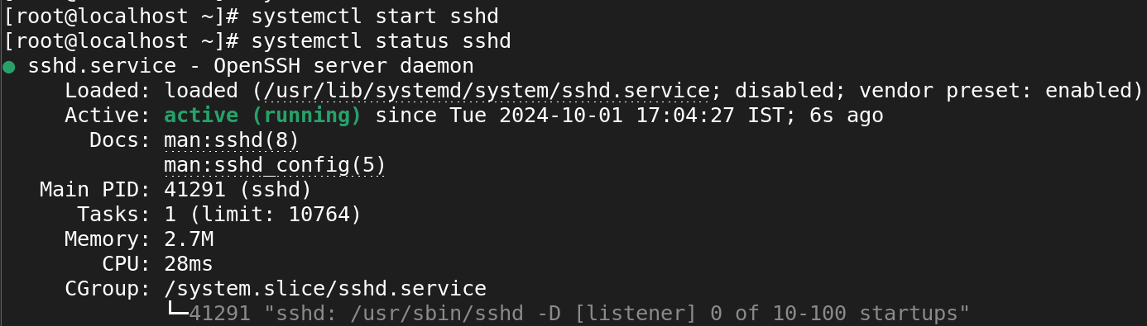

* How can you stop a running service in Linux?
* For **systemd**-based systems, **use systemctl stop <service-name>.**
* For **SysVinit** systems, **use service <service-name> stop.**

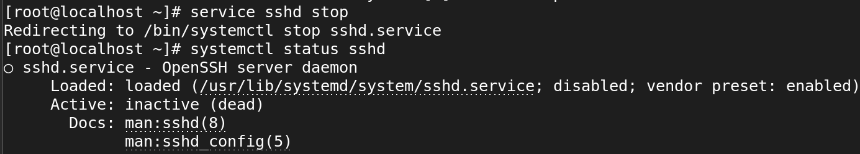

* What is the purpose of the systemctl command in Linux?

The systemctl command in Linux is a tool for controlling and managing **systemd** services. **systemd** is the system and service manager used in most modern Linux distributions, and systemctl is the primary command used to interact with it. It allows users to start, stop, restart, enable, disable, and check the status of services, as well as manage the system's state.

* How can you enable a service to start automatically at system boot in Linux?

To enable a service to start automatically at system boot in Linux, you can use the systemctl command with the enable option. This will create the necessary symbolic links so that the service starts automatically when the system boots.

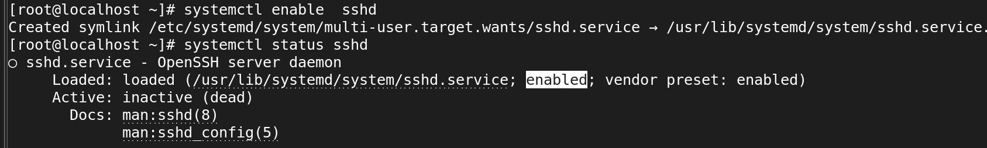

* What is the difference between a system service and a user service in Linux?

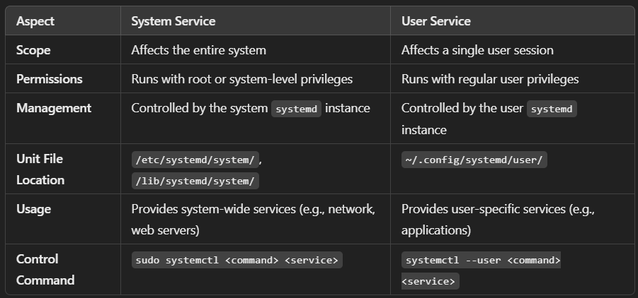

* How can you restart a service in Linux?

#systemctl restart sshd

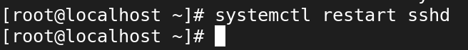

* What command is used to view the list of available services in Linux?

List all services (systemd-based): systemctl list-units --type=service --all

List active services: systemctl list-units --type=service

List services on older systems: service --status-all

installer will not have inherited the update of PATH.)

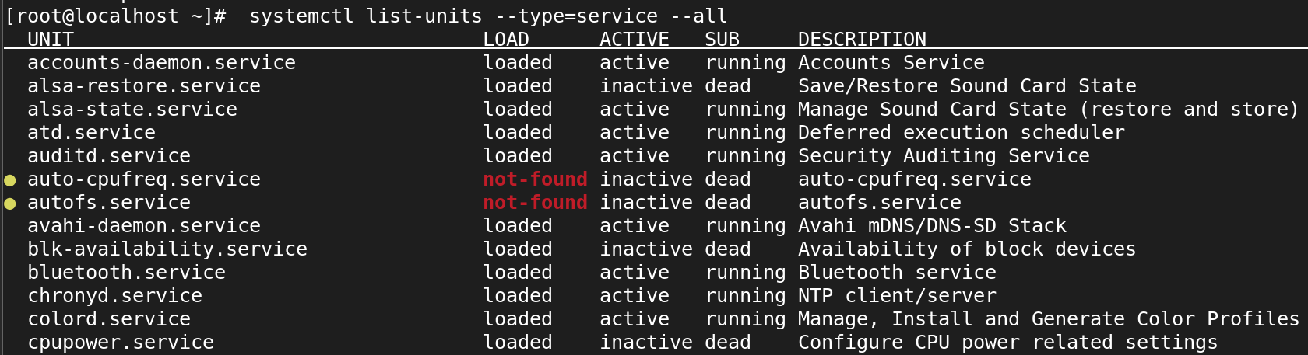

* How can you configure the behavior and settings of a service in Linux?

1. Edit the unit file using systemctl edit for service-wide behavior.
2. Modify service-specific configuration files in /etc/ or /usr/local/etc/.
3. Enable or disable the service at boot using systemctl enable or disable.
4. Make temporary changes by restarting or reloading the service.
5. Use drop-in files for more granular control of service behavior without modifying the main unit file.

* What is the purpose of the /etc/init.d directory in Linux?
* **Service Management**: Contains scripts to start, stop, and manage system services (daemons).
* **SysVinit System**: Part of the SysVinit system, used in older distributions to control services at different runlevels.
* **Runlevel Control**: Scripts can be executed with commands like service to manage services across various system states.
* **Naming Convention**: Each script is named after the service it controls (e.g., apache2, mysql).
* **Backward Compatibility**: Exists for compatibility with older scripts, even in modern systems using systemd.
* How can you create a custom service in Linux?

* How can you check the logs and debug a service in Linux?

In Linux, you can check the logs and debug a service managed by **systemd** using the journalctl command, which aggregates and displays logs from various system components, including services. Here's how you can check and debug a service:

journalctl -u <service-name>

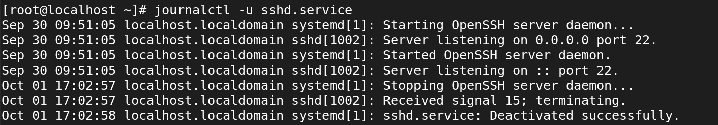

* What is the significance of service dependencies in Linux?

Service dependencies ensure that services run in the correct order, based on their needs and relationships. They play a crucial role in preventing errors and ensuring the system operates smoothly by guaranteeing that necessary services are available when required by others. Properly managing service dependencies is essential for system stability and reliable service operation.

**12.Archiving and transferring files in Linux:**

* What command is used to create a tar archive of files and directories in Linux?

**. Create a tar Archive File in Linux**

**tar -cvf etc-backup-14-09-12.tar /etc**

**c – Creates a new .tar archive file.**

**v – Verbosely show the .tar file progress.**

**f – File name type of the archive file.**

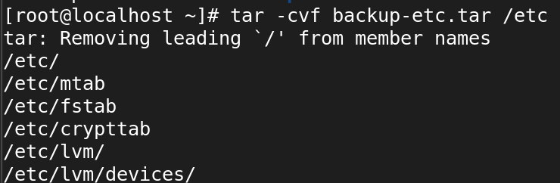

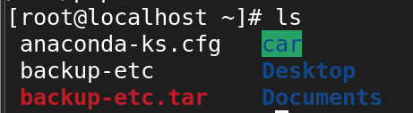

* How can you extract files from a tar archive in Linux?

Syntax:

* tar -xvf etc-backup.tar
* What is the purpose of compression when creating an archive?

Overall, compression is a valuable tool for optimizing storage and transfer of files, making it easier to handle large datasets while improving efficiency and reducing costs.

1. **Space Savings:**
2. **Faster Transfer:**
3. **Improved Performance:**
4. **Data Integrity:**

* Which command is used to compress files into a gzip archive in Linux? 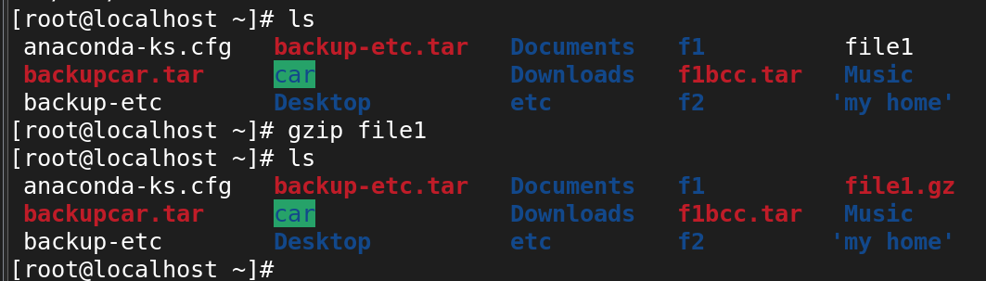
* How can you extract files from a gzip archive in Linux?

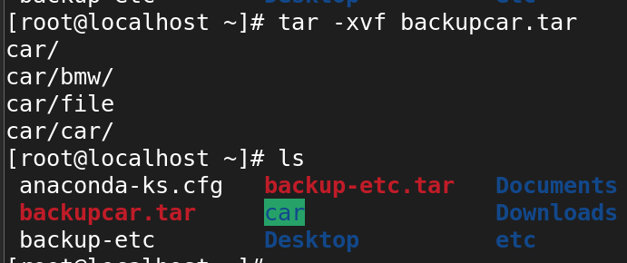

* How can you extract files from a bzip archive in Linux?

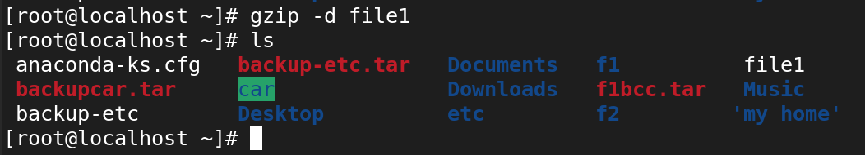

* What is the difference between a tar archive and a compressed archive?

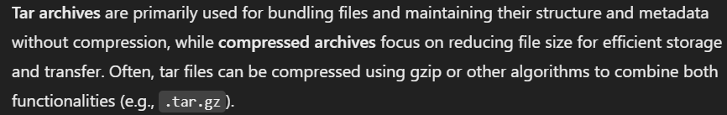

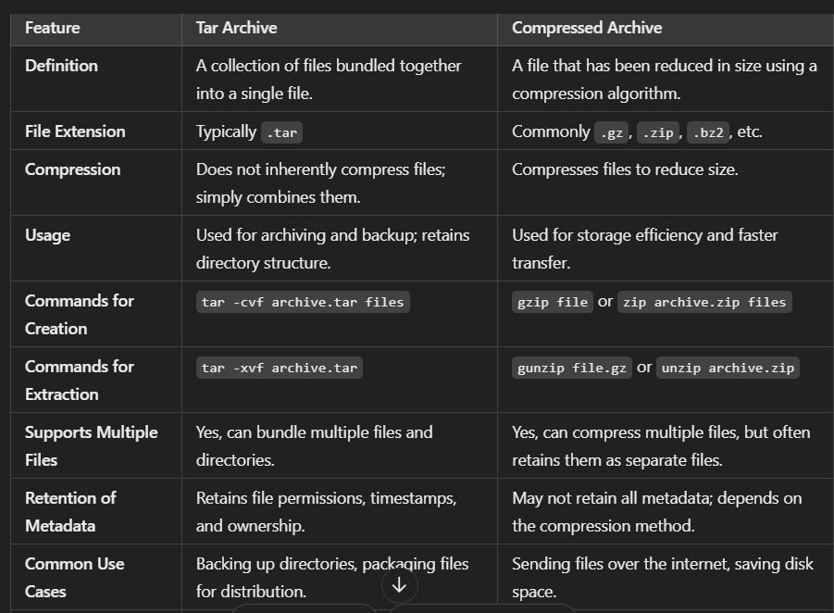

* How can you create a zip archive of files and directories in Linux?

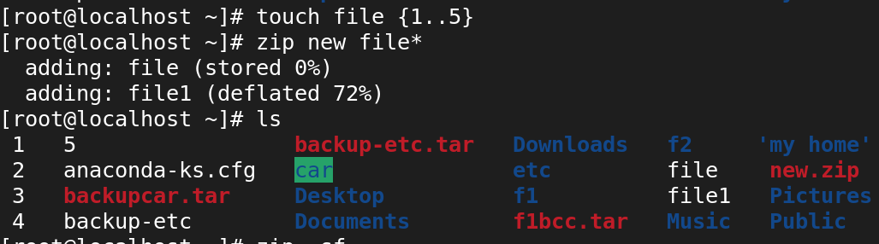

* What command is used to extract files from a zip archive in Linux?

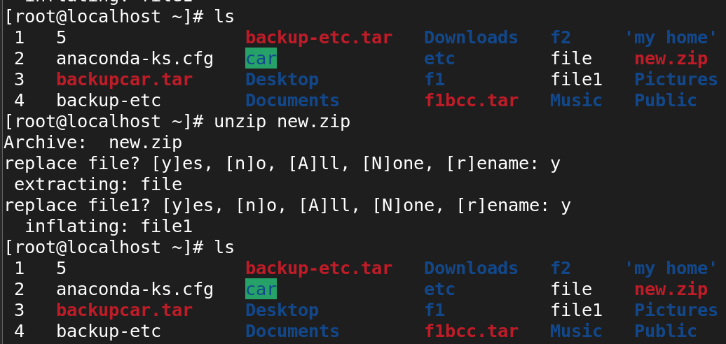

* How can you transfer files between Linux systems using the scp command?
* scp root@192.168.45.132:/root/file1 Music/

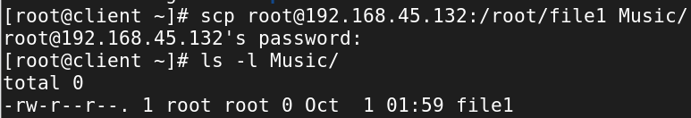

* What is the syntax for transferring a file using scp?

**Syntax:**

* scp [options] source_file user@destination_host ip : source path to destination_path



* How can you transfer an entire directory using scp?
* scp -r root@192.168.45.132:/root/dict1 Music/

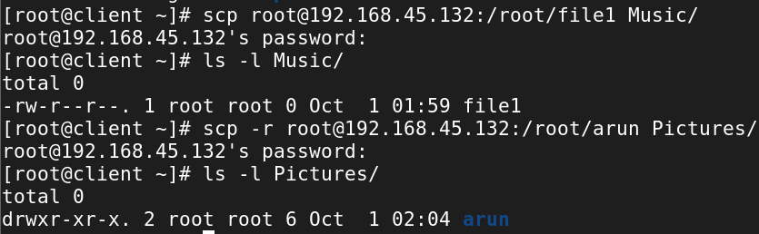

1. Analyzing and storing logs in Linux:

* What is the purpose of log files in Linux?
* **System Monitoring**: Track system performance and activities.
* **Troubleshooting**: Provide error details for diagnosing problems.
* **Security Auditing**: Record access and modifications for security reviews.
* **Event Tracking**: Maintain a history of significant system events.
* **Compliance**: Ensure adherence to regulations and policies.
* How can you view the contents of a log file in Linux?
* You can use **cat, less, more, tail, or head commands** to view the contents of log files in Linux, depending on whether you want to see the entire file, scroll through it, or monitor changes in real-time.

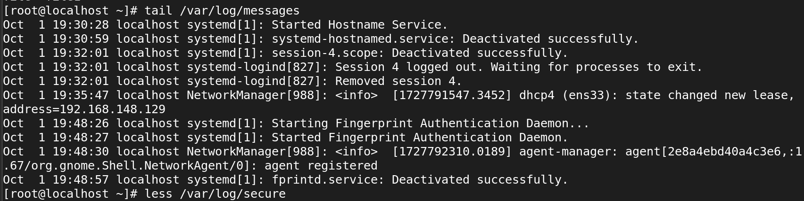

* What command is used to search for specific keywords or patterns within a log file?

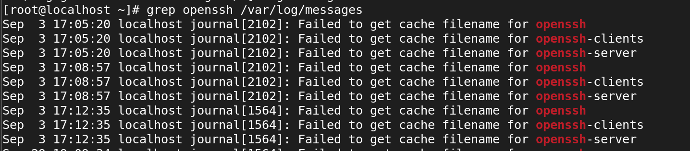

* How can you filter log entries based on specific criteria using the grep command?

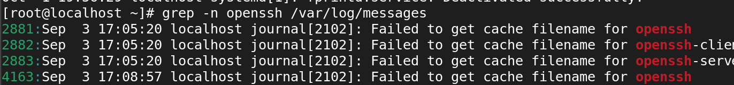

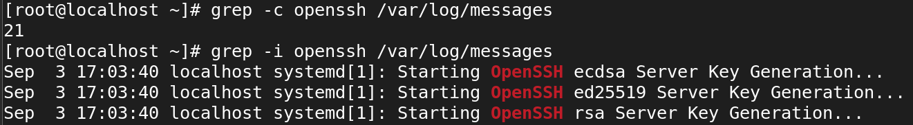

* What is the purpose of log rotation in Linux?
* **Prevent Disk Space Exhaustion**: Archives or deletes older logs to avoid excessive disk usage.
* **Improve System Performance**: Smaller log files are quicker to read and write, enhancing performance.
* **Easier Log Management**: Organizes logs for simpler searching and analysis.
* **Compliance and Auditing**: Retains historical logs for regulatory compliance and audits.
* **Backup of Old Logs**: Archives rotated logs, often in compressed form, for future reference.
* How can you configure log rotation for a specific log file?
* **Prioritization**: They categorize messages by severity, helping focus on critical issues.
* **Filtering**: Enable efficient searching and filtering of log entries based on importance.
* **Behavior Insights**: Provide insights into application performance and anomalies.
* **Troubleshooting**: Assist in diagnosing problems by highlighting errors versus informational messages.
* **Configurability**: Allow customization of log verbosity based on the environment (e.g., development vs. production).
* What is the significance of log levels in log files?

· **Severity Indication**:

· Log levels indicate the severity of an event, allowing system administrators to quickly identify critical issues that need immediate attention.

· **Prioritization**:

· Different log levels help prioritize the response to various messages, ensuring that urgent issues are addressed before less critical ones.

· **Filtering and Searching**:

· By categorizing logs, administrators can filter and search logs more effectively. This makes it easier to analyze specific types of messages (e.g., errors vs. debug information).

· **Structured Logging**:

· Log levels contribute to a structured logging approach, which improves readability and understanding of log files. This structure helps in monitoring and troubleshooting.

· **Reducing Noise**:

· Using log levels allows the suppression of less important messages in production environments, reducing noise and focusing on significant events. For instance, debug messages might be excluded in production but included in development.

· **Compliance and Auditing**:

· Certain industries require logging at specific levels for compliance purposes. By maintaining logs with appropriate levels, organizations can meet regulatory requirements.

· **Performance Monitoring**:

· Log levels can assist in performance monitoring by distinguishing between performance-related messages (like warnings about resource usage) and routine operational logs.

· **Configuration Flexibility**:

· Many logging frameworks allow configuration of log levels, enabling dynamic adjustment of what gets logged based on the operational needs or phases of development.

* How can you analyze logs for errors and warnings using regular expressions?

* What are some commonly used log files in Linux?
* **/var/log/messages**: General system activity.
* **/var/log/secure**: Authentication events.
* **/var/log/kern.log**: Kernel messages.
* **/var/log/dmesg**: Boot-time and kernel messages.
* **/var/log/cron.log**: Scheduled tasks by cron.
* **/var/log/mail.log**: Mail server activity.
* **/var/log/boot.log**: Boot process messages.
* How can you monitor log files in real-time using the tail command?
* **Monitor Performance**: Track system metrics to identify bottlenecks.
* **Enhance Security**: Detect unauthorized access and security breaches.
* **Detect Errors**: Identify application and system errors.
* **Analyze Trends**: Provide insights into usage patterns for capacity planning.
* **Alerting**: Send notifications for critical log events.
* **Centralize Logs**: Aggregate logs from multiple systems for easier management.
* **Visualize Data**: Offer graphical representations for better analysis.
* **Ensure Compliance**: Help maintain logs for regulatory requirements.
* What is the purpose of log analyzers and monitoring tools in Linux?

### ****Centralized Log Management****

* **Aggregation**: Collect and consolidate logs from multiple sources (servers, applications, network devices) into a single interface for easier management.
* **Accessibility**: Allow administrators to access logs from various systems in one place.

### 2. ****Real-Time Monitoring****

* **Alerting**: Provide real-time alerts for critical events, errors, or system failures, allowing quick response to potential issues.
* **Dashboards**: Offer visual dashboards that display system health, performance metrics, and important events in real-time.

### 3. ****Log Analysis****

* **Pattern Recognition**: Automatically analyze logs to detect patterns, anomalies, or trends that may indicate problems or security breaches.
* **Search and Filtering**: Enable users to search through large volumes of log data easily, using various filters and search criteria.

### 4. ****Performance Monitoring****

* **Resource Utilization**: Monitor system performance metrics such as CPU usage, memory consumption, disk I/O, and network traffic.
* **Trend Analysis**: Analyze historical data to identify trends over time, which can help in capacity planning and resource allocation.
* How can you store logs remotely using a centralized logging server?
* What is the role of the /var/log directory in Linux?
* What is the role of the /var/log directory in Linux?
* **Centralized Logging**: Stores log files from the system and applications.
* **System Monitoring**: Provides insights into system performance and behavior.
* **Troubleshooting**: Aids in diagnosing and resolving issues.
* **Auditing**: Records system and user activities for security audits.
* **Log Rotation**: Manages old logs to prevent excessive disk usage.
* **Debugging**: Helps developers understand application behavior.

**14. RPM packages in Linux:**

* What is an RPM package in Linux?

An **RPM package** (Red Hat Package Manager) is a package format used in Red Hat-based Linux distributions (like RHEL, CentOS, and Fedora). Key features include:

1. **File Format**: Uses the .rpm extension to package software and metadata.
2. **Package Management**: Facilitates easy installation, updating, and removal of software.
3. **Dependencies**: Specifies required libraries and packages for installation.
4. **Database**: Maintains a record of installed packages for management.
5. **Standardization**: Provides a consistent way to distribute and manage software.
6. **Tools**: Managed using command-line tools like rpm, yum, or dnf.

* How can you install an RPM package in Linux?

To install the packages using **rpm** tool **[use with .rpm extention]**

**# rpm -ivh zsh-5.8-9.el9.x86_64.rpm**

-I : install a package

-v : verbose

-h : print hash marks as the package archive is unpacked

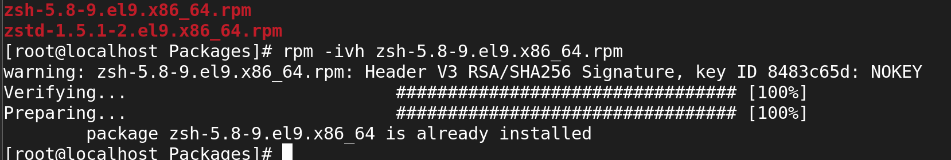

* What command is used to query information about an installed RPM package?
* rpm -qa
* q 🡪 Query
* a 🡪 queries all installed packages

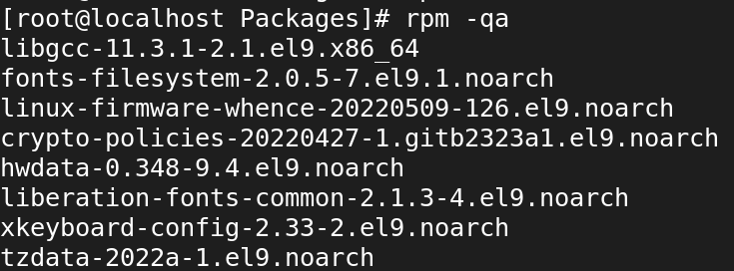

* How can you list all the files installed by an RPM package?

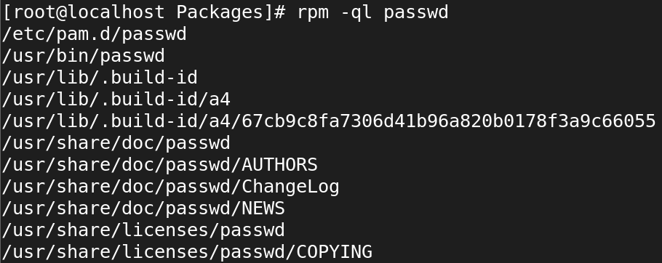

* What is the purpose of the RPM database in Linux?
* **Package Management**: Stores information about installed RPM packages.
* **Dependency Management**: Tracks package dependencies to ensure all required packages are installed.
* **Querying**: Allows users to find details about installed packages and their files.
* **Installation and Removal**: Updates the database when packages are added or removed.
* **Verification**: Checks the integrity of installed packages.
* **Rollback**: Facilitates reverting to previous package versions if needed.
* What command is used to upgrade an installed RPM package to a newer version?

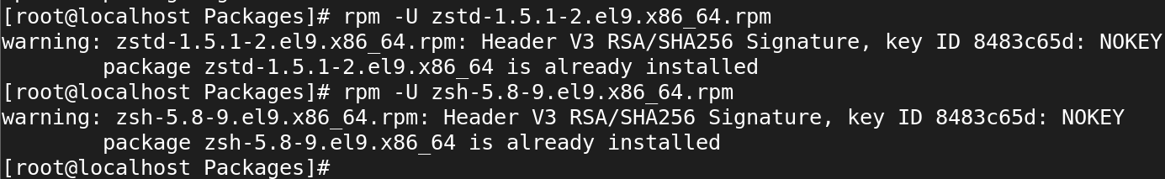

* How can you remove an installed RPM package from the system?

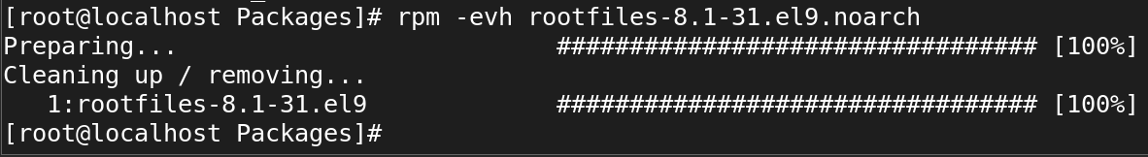

* What is the purpose of dependency resolution in RPM packages?
* **Prevent Installation Errors**: Dependency resolution checks for required packages, preventing installation failures due to missing components.
* **Ensure Compatibility**: It verifies that the correct versions of libraries and dependencies are installed, maintaining software compatibility and stability.
* **Automate Installations**: Tools like yum and dnf automatically handle dependency resolution, simplifying the installation process for users.
* **Improve System Integrity**: By ensuring that all dependencies are met, it helps maintain the integrity and functionality of the system.
* How can you list the dependencies of an RPM package?
* rpm -qpR waypipe-0.8.2-1.el9.x86_64.rpm
* q 🡪 Query a package
* p 🡪 List capabilities this package provides.
* R 🡪 List capabilities on which this package depends.

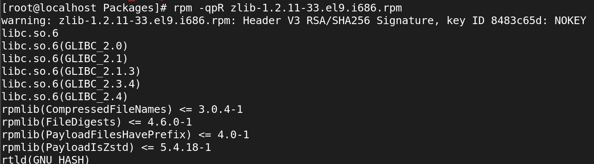

**15. Yum in Linux:**

* What is Yum and what is its purpose in Linux?

**YUM (Yellowdog Updater, Modified)** is a **package manager** used in Linux distributions like **Red Hat Enterprise Linux (RHEL), CentOS, Fedora**, and other related systems. It simplifies the process of installing, updating, removing, and managing software packages on a Linux system.

**Package Installation**: Easily install software packages from configured repositories.

**Package Updates**: Update all or specific packages on the system.

· **Dependency Management**: YUM automatically resolves and installs any dependencies required for a package.

· **Package Removal**: Remove software packages from the system

· **Repository Management**: Manage repositories that YUM uses to find and download packages.

· **Package Queries**: Search for specific packages or check the details of installed packages.

* How can you install a package using Yum in Linux?

# yum install httpd

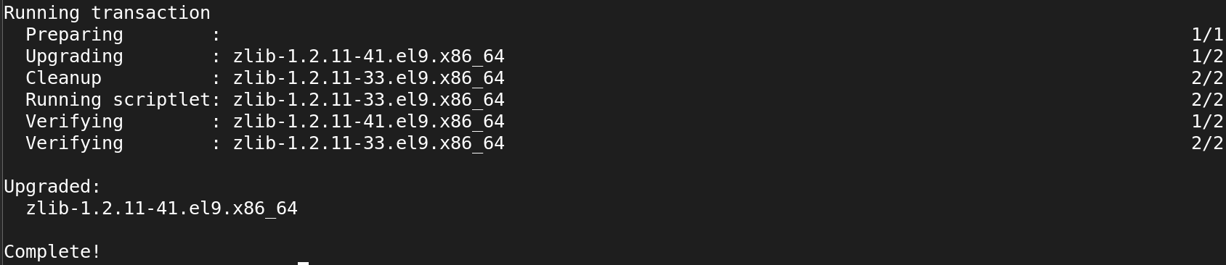

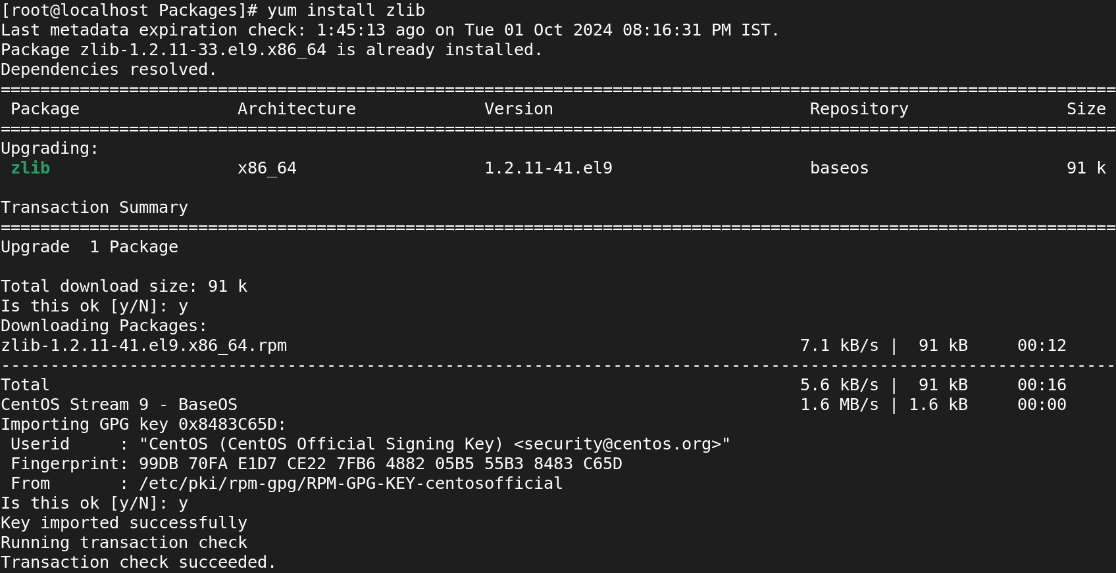

* What command is used to search for packages using Yum?

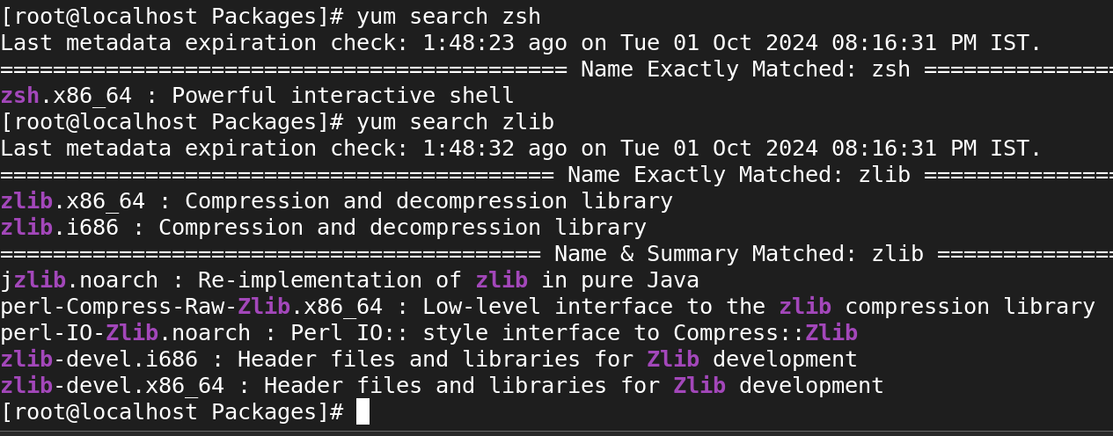

* How can you update all installed packages using Yum?

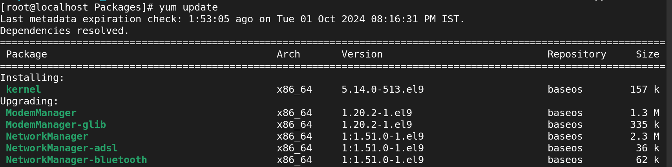

* What is the purpose of repositories in Yum?
* **Package Storage**: Centralized locations for software packages and metadata.
* **Dependency Management**: Ensures all required packages are available for installation.
* **Version Control**: Maintains multiple versions of software for users to install or upgrade.
* **Security and Updates**: Distributes updates and security patches to keep systems secure.
* **Consistency**: Provides tested and compatible software for specific distributions.
* **Configuration Management**: Allows easy configuration of multiple repositories for software sourcing.
* How can you enable or disable a repository in Yum?

**enable**

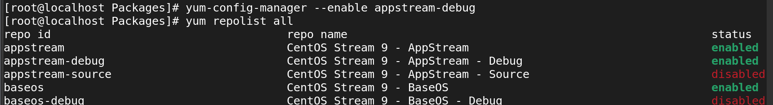

**Disable**

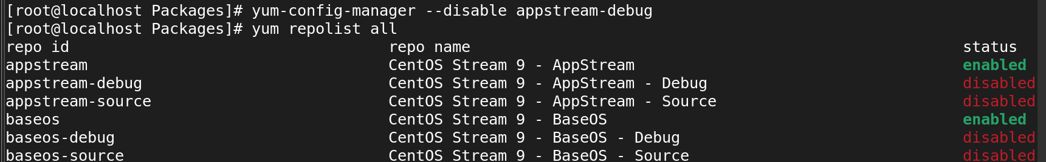

* What command is used to list the enabled repositories in Yum?
* yum repolist

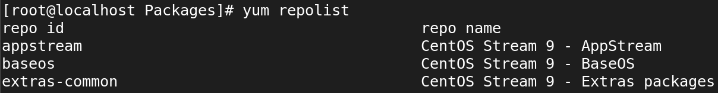

* How can you install a specific version of a package using Yum?
* **yum install httpd-1.2.3-4.el7**

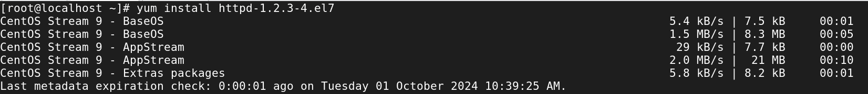

* What is the difference between Yum and RPM?

**Yum**:

* Yum is a **package manager** that handles the installation, update, and removal of packages in a system. It also resolves dependencies automatically, ensuring all required packages are installed.
* It fetches packages from configured repositories and installs them along with their dependencies.
* Suitable for maintaining a consistent package environment on a system.

**RPM**:

* RPM is a **lower-level tool** used for managing individual packages. It allows you to install, upgrade, query, verify, and remove packages.
* It doesn’t handle dependencies automatically. If a package has dependencies, you need to manually resolve and install them.
* It is often used for inspecting, building, or directly installing .rpm package files.
* How can you list the dependencies of a package using Yum?

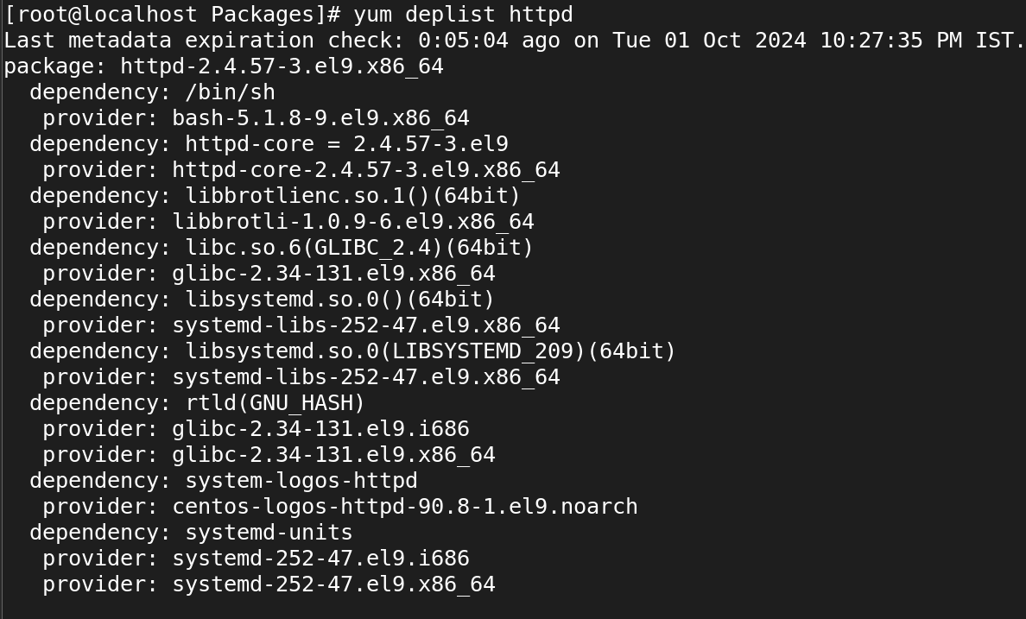

* How can you install a package group using Yum?
* yum groupinstall "group-name"

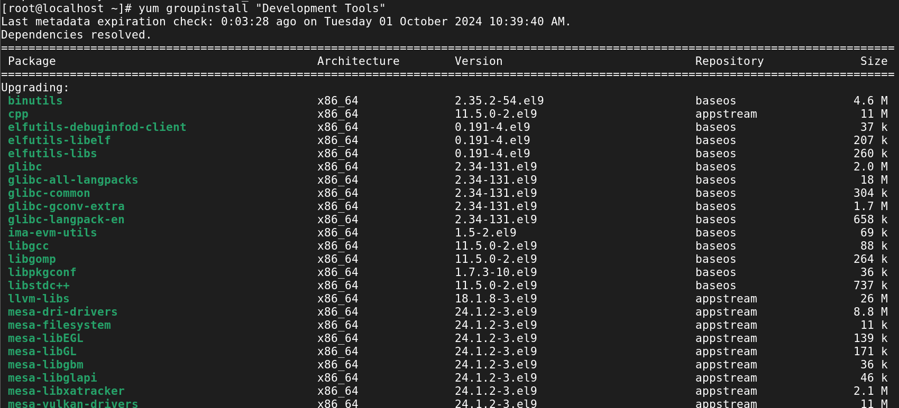

**Yum repositories in Linux:**

* What is a Yum repository in Linux?
* A **Yum repository** (short for Yellowdog Updater, Modified repository) in Linux is a central storage location that hosts packages and their metadata, which are used for software management and installation.
* It is essentially a collection of software packages (RPM files) and information about those packages, allowing yum to retrieve, install, update, or remove software on your system.
* How can you configure a custom Yum repository in Linux?
* What is the purpose of the baseurl directive in a Yum repository configuration?

**Definition**:

* The baseurl is a mandatory configuration parameter in a .repo file that points to the repository’s root directory.

**Supported Protocols**:

* It can point to a repository hosted on a web server, FTP server, or a local file system. The supported protocols are:
* **HTTP/HTTPS**: baseurl=http://mirror.centos.org/centos/7/os/x86_64/
* **FTP**: Example: baseurl=ftp://ftp.example.com/repo/
* **File**: Example: baseurl=file:///mnt/localrepo/
* How can you remove a Yum repository from the system?

* What is the role of the yum.repos.d directory in Yum repositories?
* The /etc/yum.repos.d/ directory serves as the main directory for managing repositories on a system.
* Without this directory and the .repo files it contains, Yum would not know where to look for packages.
* It allows for easy addition, removal, and configuration of repositories, making it a central place for repository management and maintenance.
* What command is used to synchronize the metadata of a Yum repository?

**yum makecache**:

* This command downloads and caches the metadata of enabled repositories, ensuring that yum has the latest information about the available packages, their versions, and dependencies.
* The metadata includes information such as package lists, dependencies, and repository configuration.
* Having this data cached allows for faster searches and queries since Yum doesn't have to retrieve metadata from the repositories every time.

Syntax:

* yum makecache
* What are some common Yum repository management commands in Linux?

**16. SSH**

* what is ssh?

**SSH (Secure Shell)** is a **network protocol** used to securely connect to remote machines and systems over an insecure network. It enables encrypted communication between the client and the server, ensuring that data (such as commands, files, and credentials) is transmitted securely.

* port number of SSH?
* default port 🡪 22
* Is it possible to change ssh port number?

Yes, it is possible to change the SSH port number. By default, SSH listens on port **22**, but you can configure it to use a different port for added security or to avoid conflicts with other services.

The configuration file is usually located at /etc/ssh/sshd_config.

#Port 22

Port 2222

Write command to login remote machine in terminal?

**ssh root@192.168.45.130**

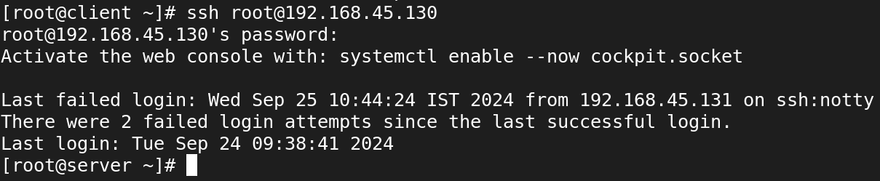

* Write command to login local machine in terminal?

To log in to the local machine using the terminal, you can simply use the ssh command with the local username and the localhost or 127.0.0.1 address (the loopback address that refers to the local machine).

ssh username@localhost

ssh username@127.0.0.1

* ssh configuration file location?

**SSH Client Configuration**

* **Location**: ~/.ssh/config
* **Description**: This file contains configuration settings for the SSH client, allowing users to customize their SSH connections. You can specify options such as host aliases, user names, ports, and identity files for specific remote hosts.

**SSH Server Configuration**

* **Location**: /etc/ssh/sshd_config
* **Description**: This file contains the configuration settings for the SSH server (sshd). It controls how the SSH server behaves and manages security settings, authentication methods, and more.
* configure SSH key based authentication? write path of key file location? server1-user:admin1 to server2-user:admin1

* what is the command to generate the ssh key?

**Syntax:**

* ssh-keygen

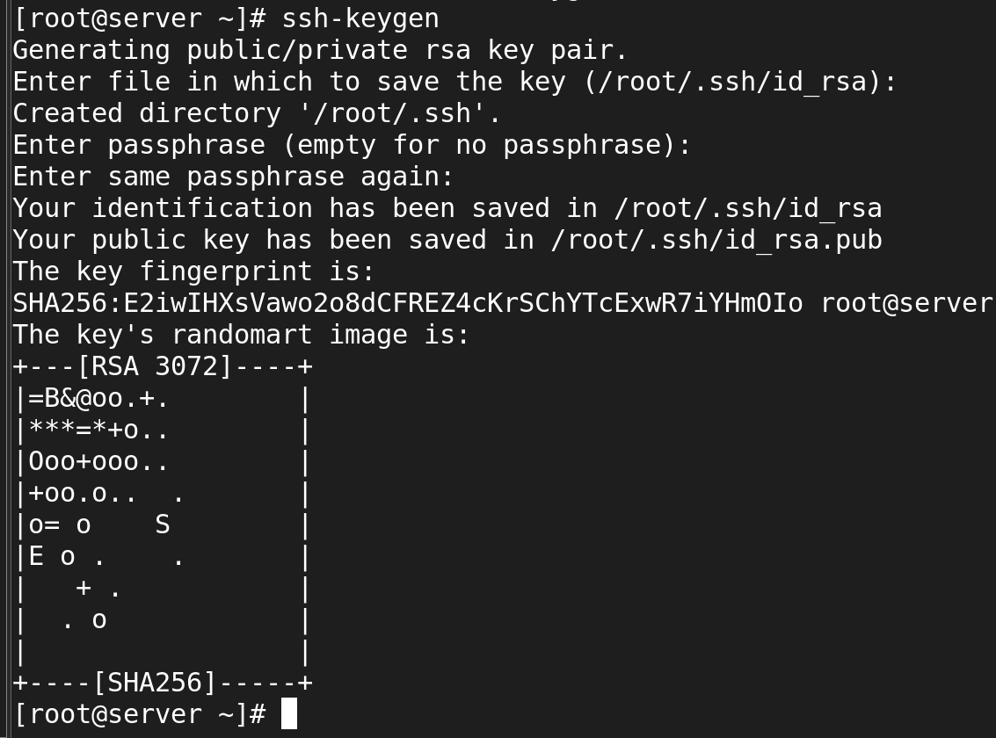

* what is the command to copy the keys to remote machine? 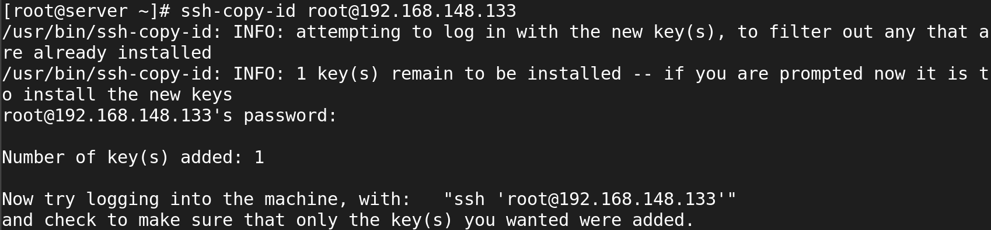
* when you generate the key what are files will be create?

**Private Key**

* **File Name**: id_rsa (or another name if specified)
* **Location**: ~/.ssh/id_rsa
* **Description**: This file contains the private key, which should be kept secure and never shared with anyone. It is used to authenticate your identity when connecting to an SSH server. The private key must be protected from unauthorized access.

**Public Key**

* **File Name**: id_rsa.pub (or another name with .pub extension if specified)
* **Location**: ~/.ssh/id_rsa.pub
* **Description**: This file contains the public key, which can be shared with remote SSH servers to allow authentication. You will copy the contents of this file to the authorized keys file on the remote server to enable key-based authentication.
* what is the ssh daemon name?
* **sshd** is the server-side component of the SSH protocol, responsible for handling incoming SSH connections, managing user authentication, and providing secure access to the system over a network.
* It listens for connection requests on a specified port (default is port **22**) and initiates secure communication sessions with SSH clients.
* write ssh service-related commands which you know?

sudo systemctl start sshd

sudo systemctl stop sshd

sudo systemctl restart sshd

sudo systemctl status sshd

sudo systemctl reload sshd

sudo systemctl enable sshd

sudo systemctl disable sshd

* Disable ssh root login?

sudo vi /etc/ssh/sshd_config

PermitRootLogin no

sudo systemctl restart ssh

* How to disable password-based authentication?

To disable password-based authentication for SSH and enforce key-based authentication, follow these steps:

vi /etc/ssh/sshd_config

#PasswordAuthentication yes

PasswordAuthentication no

PubkeyAuthentication yes

sudo systemctl restart sshd

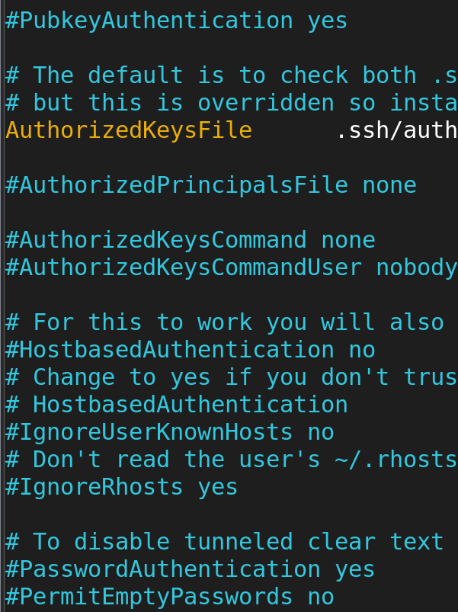

* Allow ssh access to particular user? (user1, user2, user3)



sudo systemctl restart sshd

ssh user1@your_server_ip

* Change ssh port number 4044 and try to ssh login.



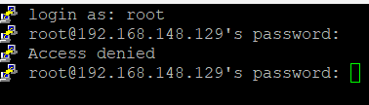

* How to start, stop, restart, check the status of ssh service?

### **Start the SSH Service**

* To start the SSH service (sshd)
* systemctl start sshd



### **Stop the SSH Service**

* To stop the SSH service
* systemctl stop sshd



### **Restart the SSH Service**

* To restart the SSH service, which is useful after making configuration changes
* systemctl restart sshd



### **Check the Status of the SSH Service**

* To check the current status of the SSH service, use:
* systemctl status sshd

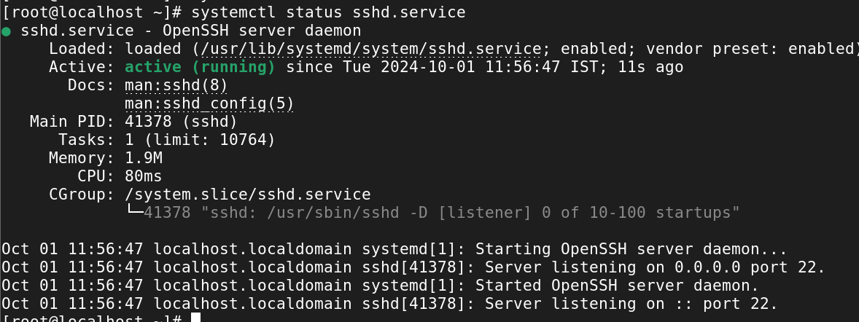

* How to start the ssh service permanently?

Syntax:

* systemctl enable --now sshd

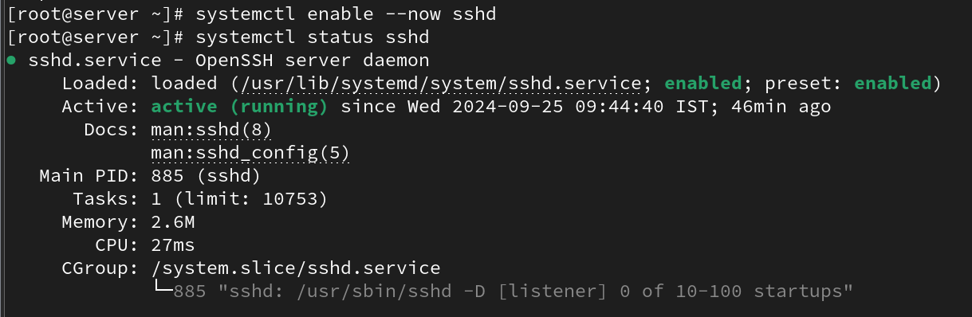

* How to stop the ssh service permanently?

Syntax:

* systemctl disable --now sshd

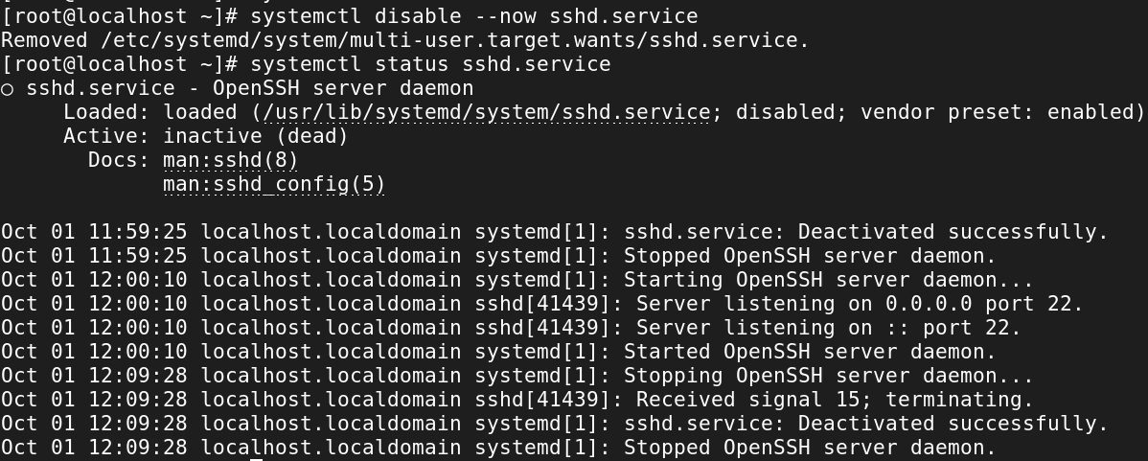

**17. Analyzing and storing logs in Linux:**

* What is the purpose of log files in Linux?
* Log files are essential for maintaining, troubleshooting, securing, and optimizing Linux systems.
* They provide a detailed record of system activity and serve as a critical tool for system administrators in managing and safeguarding their environments.
* Proper management and analysis of log files can significantly enhance the reliability and security of Linux systems.
* How can you view the contents of a log file in Linux?

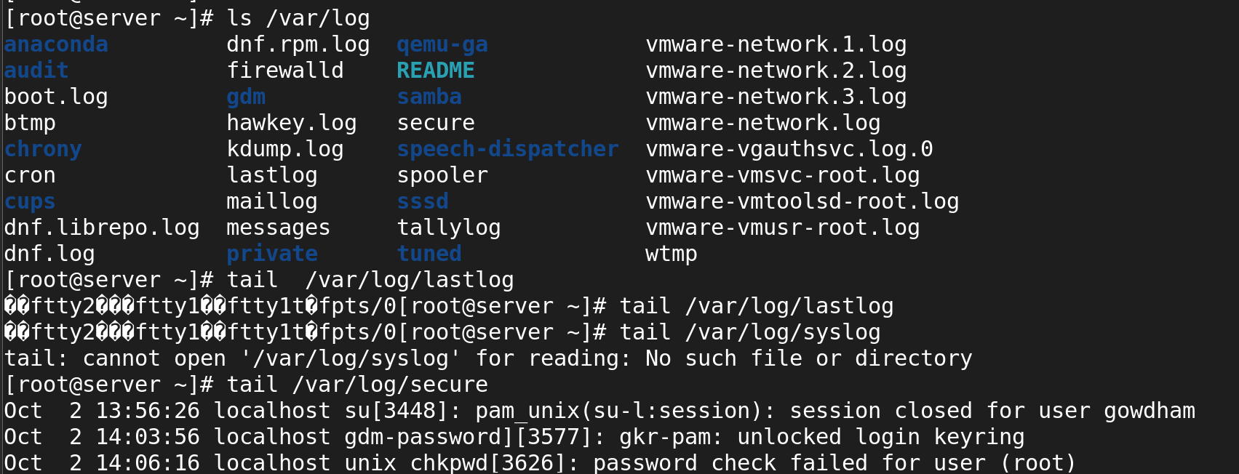

* What command is used to search for specific keywords or patterns within a log file?

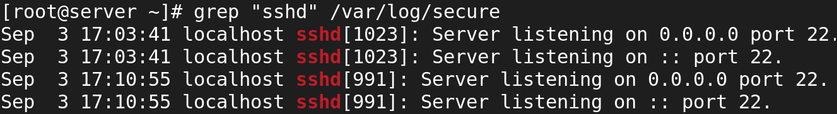

* How can you filter log entries based on specific criteria using the grep command?

grep -i "sshd" /var/log/syslog



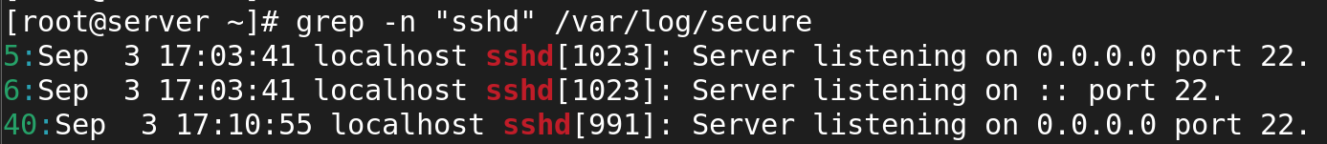

Filter using date and time

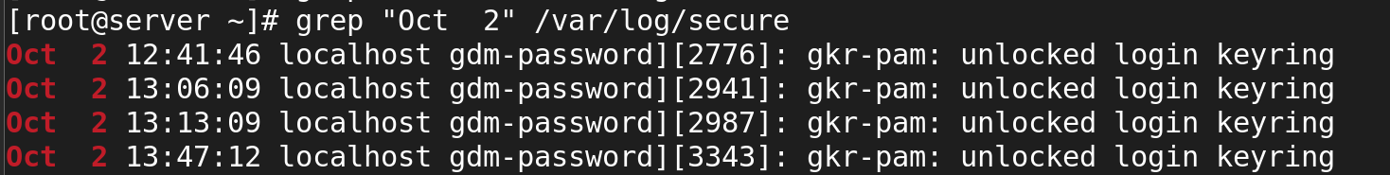

* What is the purpose of log rotation in Linux?
* **Prevent Disk Space Issues**: By compressing and deleting old logs, log rotation prevents disk space from being exhausted due to excessively large log files.

· **Improved Performance**: Smaller log files are easier to handle for both system processes and administrators. Large logs can slow down processes that need to read or write to them.

· **Organized Log Management**: Log rotation maintains an organized history of logs by renaming old logs with timestamps or numbers and moving them to an archive.

· **Automated Maintenance**: Log rotation automates the process of archiving and removing logs, reducing the need for manual intervention by administrators.

· **Compliance**: Some industries require retaining logs for a specific time for auditing purposes. Log rotation can help automate retention policies.

* How can you configure log rotation for a specific log file?

* What is the significance of log levels in log files?
* **Prioritization**: Indicate the severity of events, helping users focus on critical issues first.
* **Troubleshooting**: Allow filtering of logs to quickly identify and resolve problems.
* **Readability**: Enhance organization, making it easier to scan for relevant information.
* **Customizable Logging**: Enable different logging levels for various environments (e.g., DEBUG for development, ERROR for production).
* **Compliance**: Help meet regulatory requirements by documenting important actions and errors.
* How can you analyze logs for errors and warnings using regular expressions?

To analyze logs for errors and warnings using regular expressions in Linux, you can use tools like grep and egrep. These commands allow you to search for specific patterns in log files, making it easier to identify important entries such as errors or warnings.

* What are some commonly used log files in Linux?
* **/var/log/messages**: General system messages and logs useful for troubleshooting.
* **/var/log/secure**: Authentication-related messages, including login attempts, important for security auditing.
* **/var/log/boot.log**: Logs from the boot process, useful for troubleshooting startup issues.
* **/var/log/mail.log**: Logs for mail servers, useful for diagnosing email-related issues.
* **/var/log/cron.log**: Logs related to cron jobs, tracking scheduled tasks.
* **/var/log/dmesg**: Kernel ring buffer messages, useful for diagnosing hardware issues.
* How can you monitor log files in real-time using the tail command?

You can monitor log files in real-time using the tail command with the -f option. This allows you to continuously view new lines as they are added to the log file, which is useful for tracking the live output of logs, such as system events or application logs.

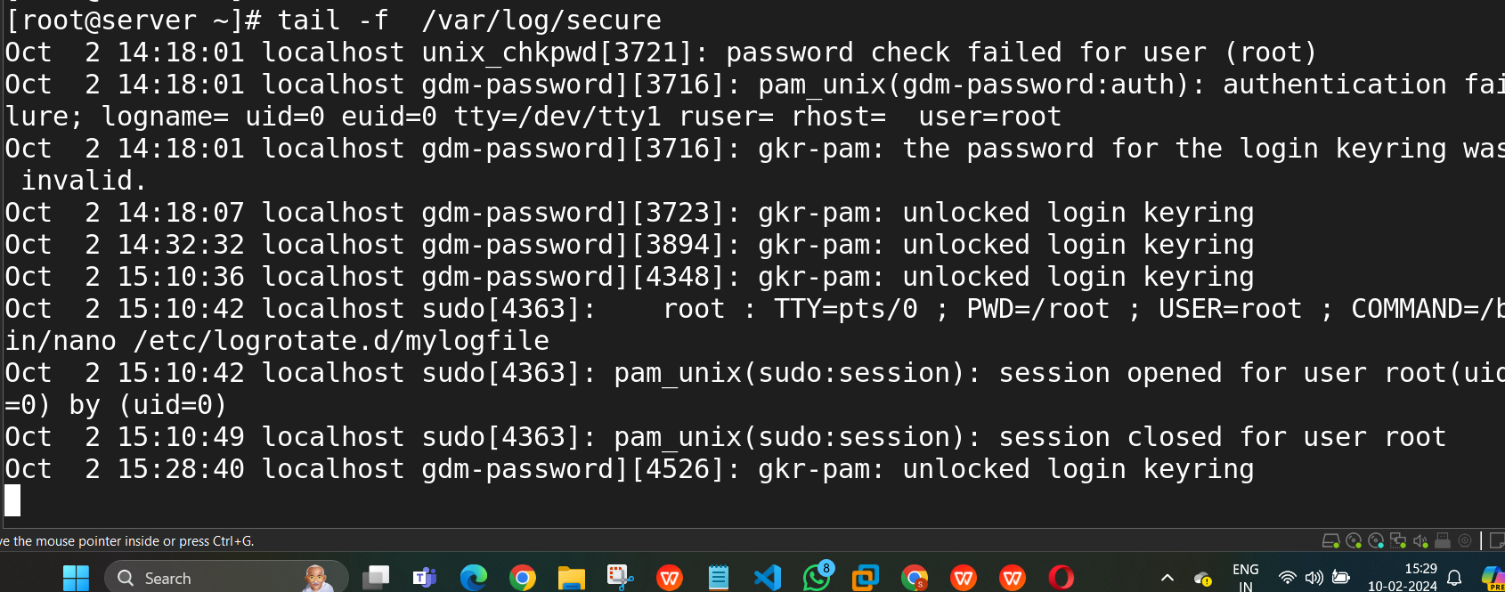

* What is the purpose of log analyzers and monitoring tools in Linux?
* **Centralized Log Management**: Aggregate logs from multiple sources for easier management.
* **Real-Time Monitoring**: Detect anomalies and alert administrators immediately.
* **Enhanced Troubleshooting**: Simplify issue diagnosis by identifying patterns in logs.
* **Performance Optimization**: Analyze performance-related logs to improve system efficiency.
* **Security Auditing**: Monitor logs for unauthorized access and security threats.
* **Compliance Reporting**: Generate reports to meet regulatory compliance requirements.
* **Data Visualization**: Provide dashboards for visual representation of log data.
* **Historical Analysis**: Analyze long-term trends in system behavior.
* How can you store logs remotely using a centralized logging server?
* **Choose a Logging Solution**: Select a tool like the ELK Stack, Graylog, or Fluentd.
* **Set Up the Central Logging Server**: Install the logging solution on a dedicated server with adequate resources.
* **Install Logging Agents on Client Machines**: Use agents like Filebeat, Fluentd, rsyslog, or Syslog-ng.
* **Configure the Logging Agents**: Point the agents to the central server and specify the log files to monitor.
* **Adjust Firewall Settings**: Open necessary ports on the logging server for log traffic.
* **Test the Configuration**: Start the agents and verify that logs are being received by the server.
* **Set Up Retention Policies**: Configure how long to keep logs to manage storage.
* **Monitor and Alert**: Set up alerts for issues like high log volume or processing errors.
* What is the role of the /var/log directory in Linux?
* The /var/log directory in Linux serves as a central location for logging files generated by the system, applications, and services.
* It plays a crucial role in system administration and troubleshooting by storing logs that help track system activity, errors, warnings, and various other events.

**18. ACL**

* Set a read and write ACL for user bob on the file /home/user1/report.txt.

To set a read and write Access Control List (ACL) for user bob on the file /home/user1/report.txt, you can use the setfacl command.

# setfacl -m u:bob:rw /home/user1/report.txt

* Remove all ACL entries for the file /var/log/syslog.

setfacl -b /var/log/syslog

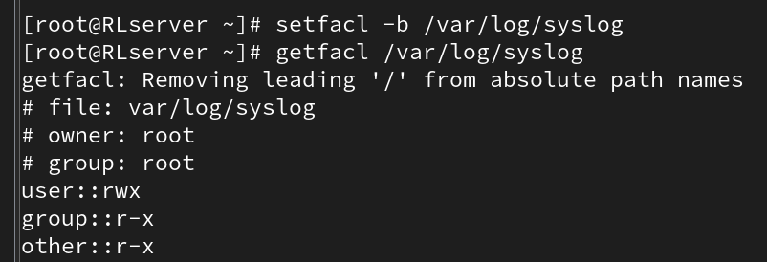

* Grant the group developers read, write, and execute permissions on the directory /home/projects/, including all files and subdirectories.

* Set a default ACL that gives the group marketing read-only access to all new files created in the directory /shared/marketing/.

# setfacl -d -m g:marketing:r /shared/marketing/

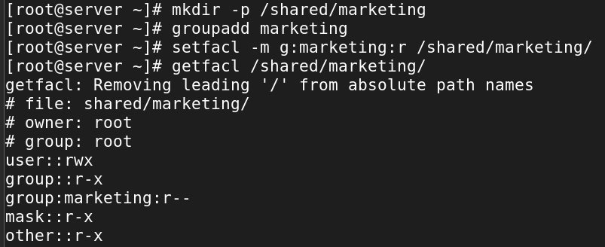

* Check and display all the ACL entries on the file /etc/hosts.

# getfacl /etc/hosts

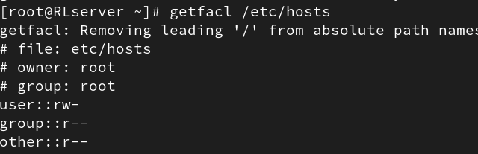

* Set the user alice to have no permissions on the file /home/user2/confidential.txt, even though she belongs to the users group which has permissions.

# setfacl -m u:alice:0 /home/user2/confidential.txt

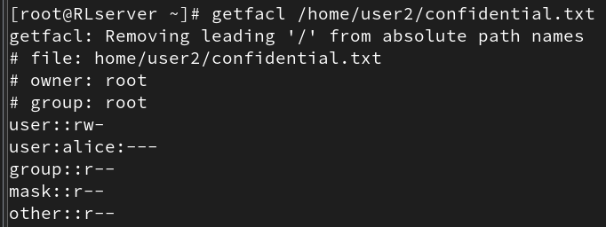

* Grant the user tom execute permission on the directory /scripts/ and all files inside it.

# setfacl -R -m u:tom:x /scripts/

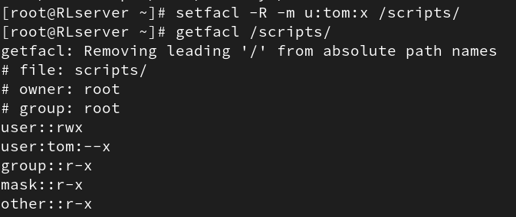

* Modify the ACL of the file /data/project.txt to grant the user susan read and write permissions, but not execute permissions.

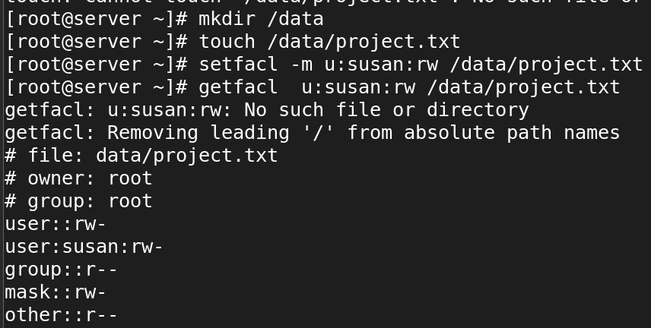

* Set an ACL for the group admin to have full permissions (read, write, execute) on the file /etc/passwd, while keeping the original permissions for other users intact.

To set an Access Control List (ACL) for the group admin to have full permissions (read, write, execute) on the file /etc/passwd while keeping the original permissions for other users intact, you can use the setfacl command.

# setfacl -m g:admin:rwx /etc/passwd

* Create an ACL that removes write permissions for the group staff on the file /tmp/notes.txt, but allows the owner to retain full permissions.

To create an Access Control List (ACL) that removes write permissions for the group staff on the file /tmp/notes.txt, while allowing the owner to retain full permissions.

#setfacl -m g:staff:rw /tmp/notes.txt

**Network**

========

* Add additional ethernet card and assign static ip

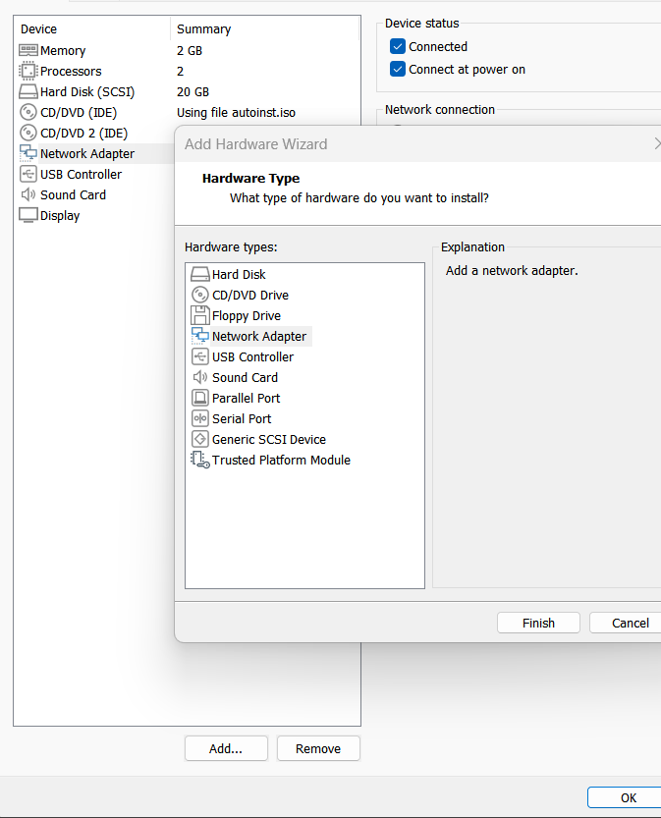

* Add additional ethernet card and assign dynamic ip

#ifconfig or #ip a

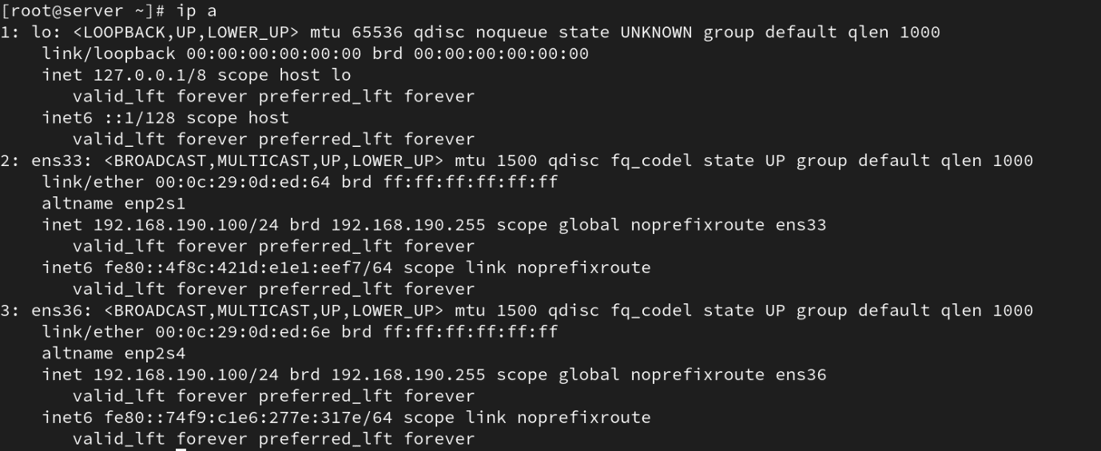

* how to check the server IP also show the current IP details?

# route -n

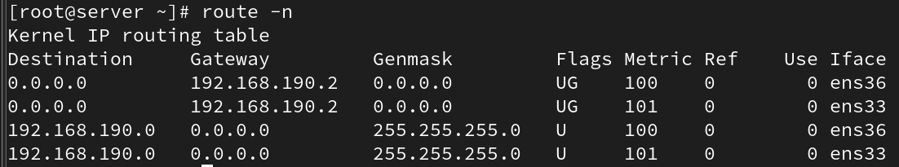

* how to check the server routes also show current route details?

# route -n



* add two ethernet card ans assignee one ip?

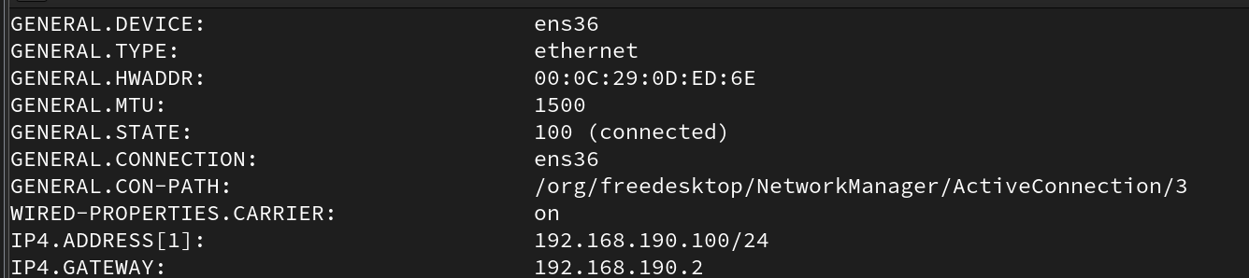

* assign two ip address for one Ethernet card?

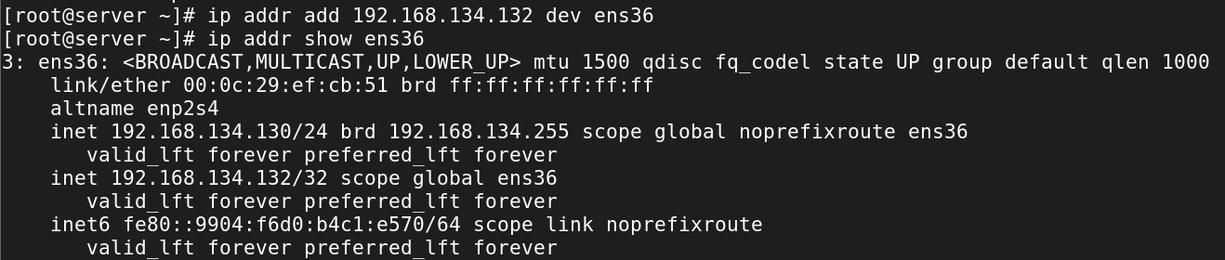

* how to check the server hostname

#hostname

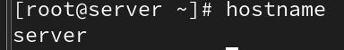

* change server hostname as server.glotechcorp.com permanently

#hostnamectl set-hostname server.glotechcorp.com

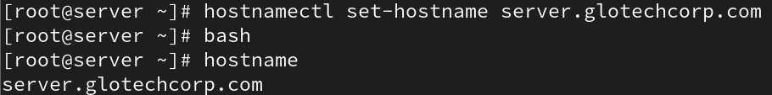

**Find**

====

* How would you use the `find` command to search for all files with the `.txt` extension in the `/home` directory?

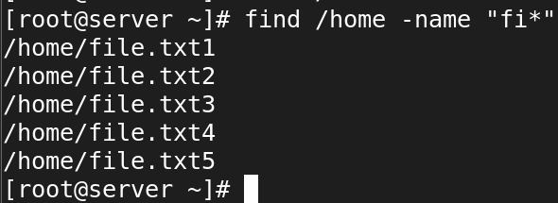

* Write a command using `find` to search for files larger than 200MB in the `/var` directory.



* Use `find` to locate all files in the `/etc` directory that were modified within the last 7 days.

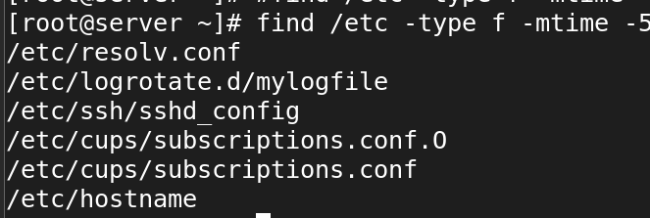

* How can you use `find` to search for files owned by a specific user, for example, `user1`, in the `/home` directory?

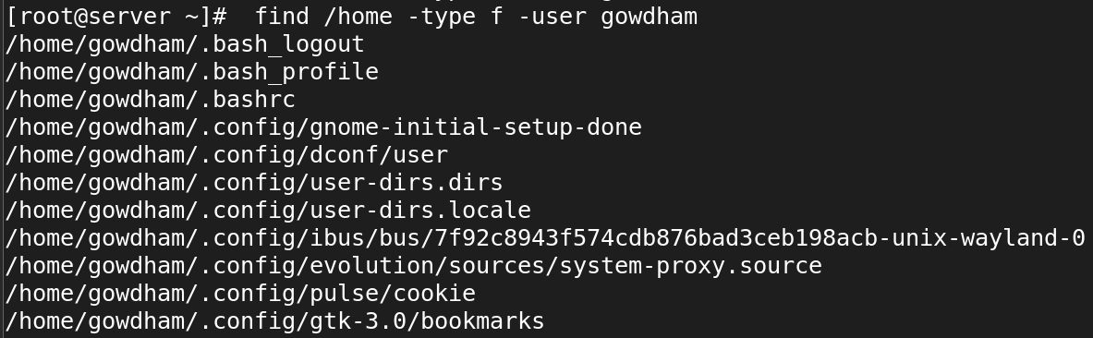

* Find all symbolic links within the `/usr` directory using the `find` command

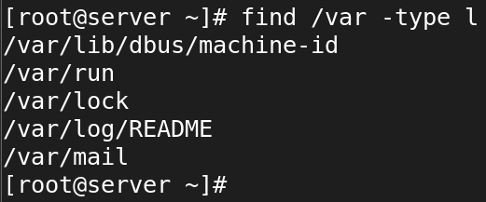

* Write a `find` command to delete all `file` files in the `/home` directory.

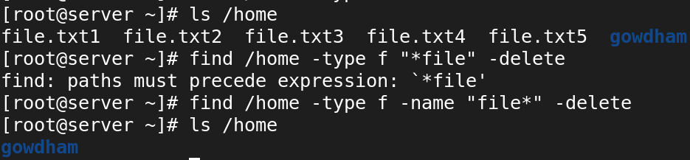

* How would you use the `find` command to locate files with the permissions `644` within `/etc`?

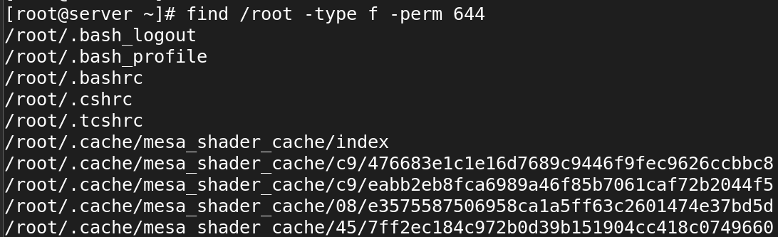

* Use the `find` command to locate all files named `index.html` starting from the root directory (`/`).

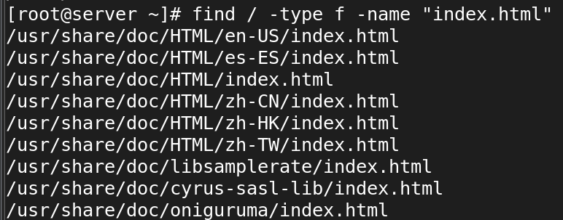

* Write a command using `find` to search for directories (not files) named `backup` within the `/var` directory.

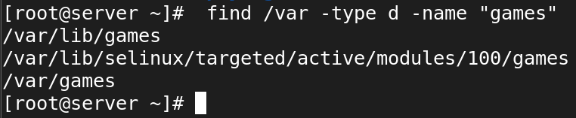

* How would you find all empty files within the `/home/user/Documents` directory using `find`?

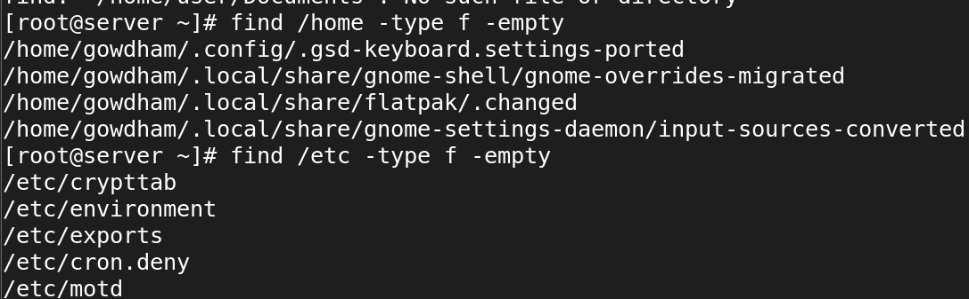

**Locate**

======

* 1. How would you use the `locate` command to find all files containing the name `bashrc`?

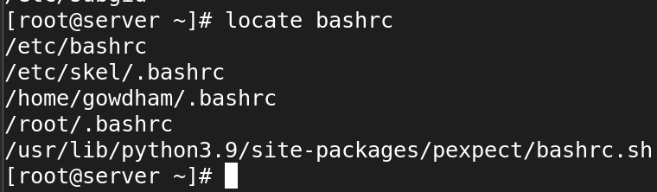

* 2. Write a `locate` command to search for files with the `.conf` extension on your system.

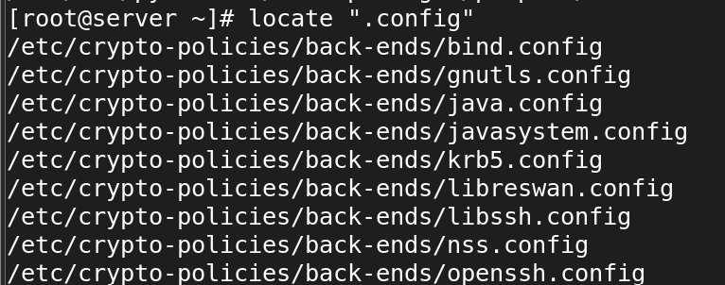

* 3. How can you use `locate` to find all occurrences of a file named `hosts` in the filesystem?

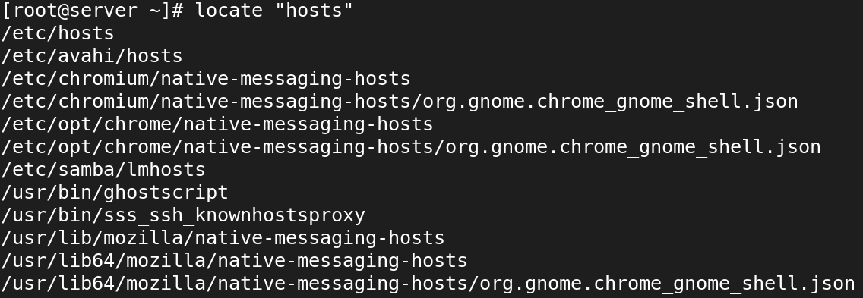

* 4. Use the `locate` command to find directories containing the name `bin` in their path.

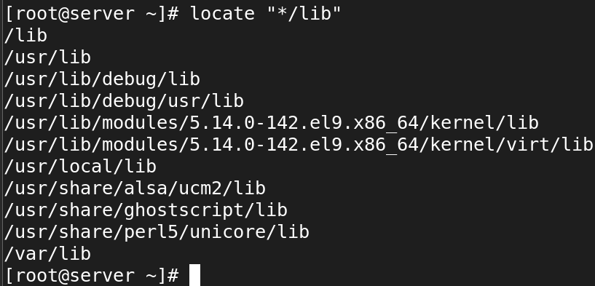

* 5. Write a `locate` command to find files related to the program `ssh`.

#locate ssh

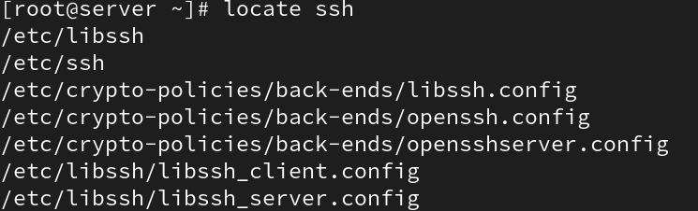

* 6. How would you use `locate` to search for files that were updated in the last 24 hours?

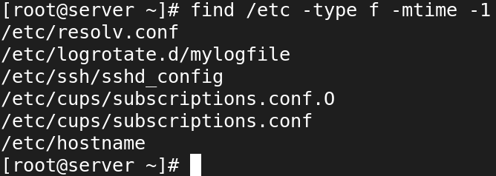

* 7. Use the `locate` command to find all files and directories containing the word `apache`.

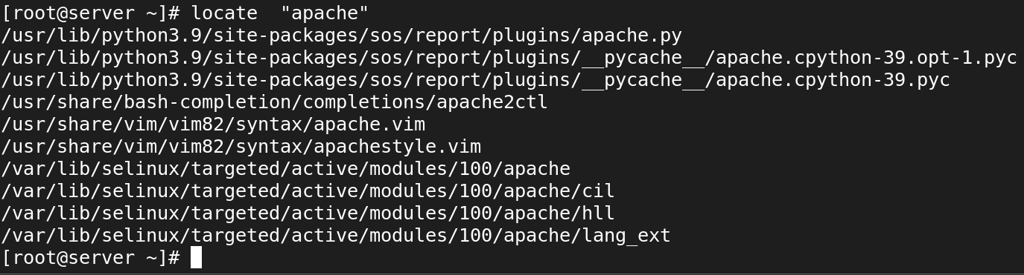

* 8. Write a `locate` command to search for all files in the `/usr` directory that contain the string `lib`.

# locate /usr/*lib*

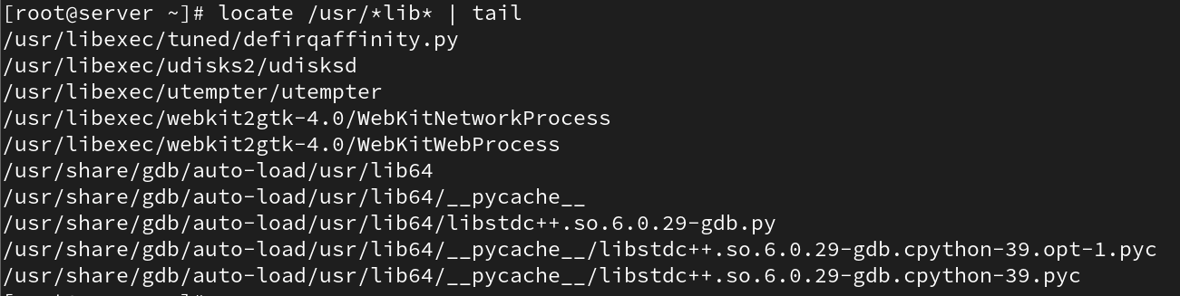

* 9. How can you update the `locate` database manually before performing a search?

#updatedb



* 10. Write a `locate` command to find all files with the `.jpg` extension.

# locate "*.jpg"

